

Sprinter Van Ambulance

Operations Manual
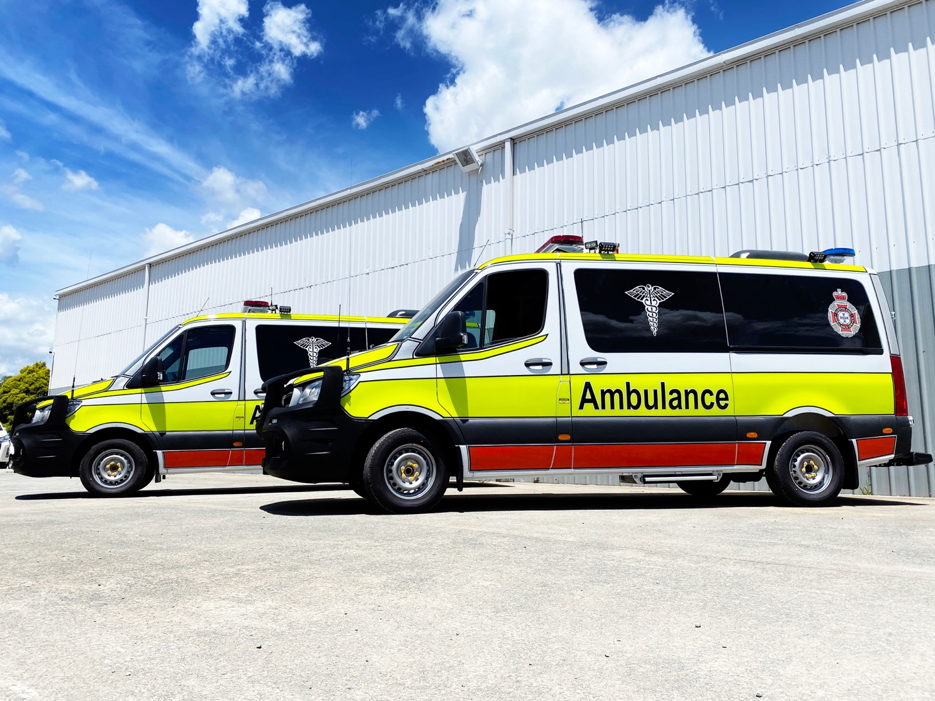

Preface
This manual details the operation of the Queensland Ambulance Service Vehicle for the staff of QAS. The information provided is to gain a clear and detailed understanding of the operations of the 419
Mercedes Benz Van Ambulance. It provides information on:
- Warranty conditions and maintenance
- Vehicle dimensions
- Safety features
- Warning devices
- Ambulance conversion features
- The exterior features of the vehicle
- Climate control
- Electrical features
The SEVA Mercedes-Benz 419 Van Ambulance is manufactured to comply with all relevant Australian and Standards Australian Design Rules (ADR’s). It is important that basic maintenance schedules are followed, for the vehicle to give long and reliable service. Additionally:
ANY OPERATIONAL PROBLEMS WITH THE VEHICLE MUST ALWAYS BE OBSERVED AND REPORTED
DO NOT ASSUME THAT A GAUGE OR WARNING LIGHT IS FAULTY
You are strongly advised to study this manual carefully before operating the vehicle.
  - IMPORTANT NOTICE
This document is based on the latest vehicle specification and information and SEVA has made every effort to articulate this information in a safe and accessible manner. However, the Company holds no responsibility for any action or claim arising from the use of this product or information contained in it.

Contents

1. Preface 2
2. Contents 3
3. Mercedes Benz Technical Notices 6
3.1 Flat Battery 6
3.2 Jump Starting 6
3.3 Spare Wheel 7
3.4 Remote Locking System 7
3.5 Rear Doors 8
4. Warranty Conditions and Maintenance 8
4.1 Warranty 8
4.2 Maintenance 8
5. Vehicle Specifications 9
6. Exterior Views 10
6.1 Front View 10
6.2 Rear View 11
7. Audio-Visual Warning Systems 12
7.1 Emergency Lighting (Exterior Layout) 12
7.2 Door Ajar Warning Device 12
7.3 Operation of Audio-Visual Warning Systems 12
7.4 Emergency Lighting 12
7.5 Emergency Sirens 13
7.6 Conspicuity 14
8. Climate Control (A/C) 14
8.1 Drivers Compartment Climate Control 14
8.2 Rear Climate Control (Mercedes Roof Mounted Unit) 15
8.3 Compartment Heater Controls and Operation 15
9. Drivers Compartment Layout 17
9.1 Centre Console 17
9.2 Radio Head 18
9.3 Reverse camera Monitor 18
9.4 Internal camera 19
9.5 Cooling Compartment/Refrigerator 19
10. Patient Compartment layout 21
10.1 General Storage 21
10.2 Overhead Drivers Side Rear– Airways 22
10.3 Rear Facing Paramedic Seat 22
10.4 Passenger Side Wall Side Cabinetry 23
10.5 Driver’s Side Rear Cabinetry 24
10.6 Passenger Side Sliding Door – Grab-N-Go Locker-Emergency Equipment 25
10.7 Forward Facing Attendants Seat/Linen Plinth 25
10.8 Workstation 26
11. Equipment Locations 27
11.1 Drivers compartment 27
11.2 Patients compartment 29
12. Passenger Compartment Attendant Seats – Operation 36
12.1 Rearward facing Attendant Seat 36
12.2 Forward Facing Attendant Seat 36
13. Oxygen System 37
13.1 Oxygen – cylinder storage 37
13.2 Oxy changeover valve 37
13.3 To replace cylinders 38
13.4 Oxygen Outlets 38
14. Other Vehicle Features 39
14.1 IV Hooks 39
14.2 Fire Extinguisher 39
14.3 Side Steps 39
14.4 Exterior Vehicle Cleaning 40
15. Electrical System 40
15.1 Functions not controlled by switch panels 40
15.2 Main Control Panel – Driver’s Compartment 41
15.3 Driver Panel LEDs 42
15.4 EMERG START – Auxiliary battery 43
15.5 EMERG LIGHT 43
15.6 Patient Compartment – Drivers side rear pillar switch panel 43
15.7 Patient Compartment – Rear Speaker Panel 44
15.8 12V Outlets 46
15.9 Batteries 46
15.10 240 Volt Inverter 46
15.11 Coolant valve 47
15.12 Battery Charger 47
15.13 Interior Lighting 49
15.1 Exterior Vehicle Cleaning 49

Mercedes Benz Technical Notices

Flat Battery
The interior CAN Bus Systems fitted to the 419 Sprinter, means leaving the ignition key in the EIS (Ignition Control Unit) overnight will cause current draw from the vehicles battery and may lead to a none start situation.

Jump Starting
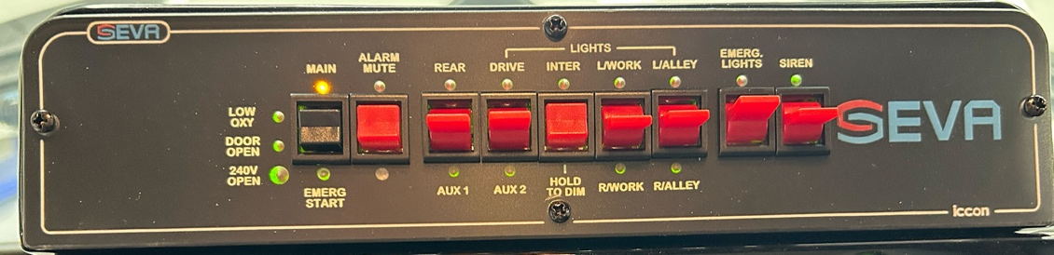
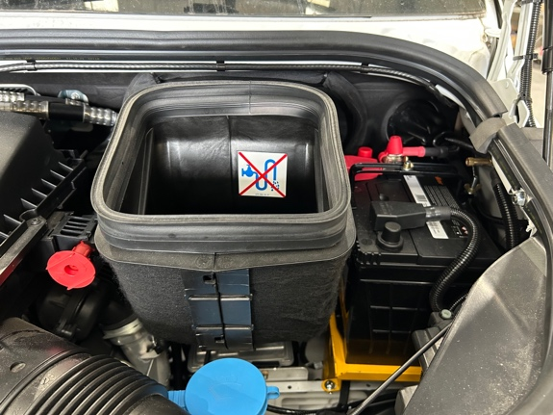
It is not necessary to access the main battery to jump start the vehicle. The remote is located in the engine bay on the passenger side. The positive power source (1) should be first connected to the red connector on the jump starting point and then the negative lead should be connected to the earth point (2) located on the passenger side inner fender panel. For more info please see the Mercedes operator manual.
Emergency Start Button

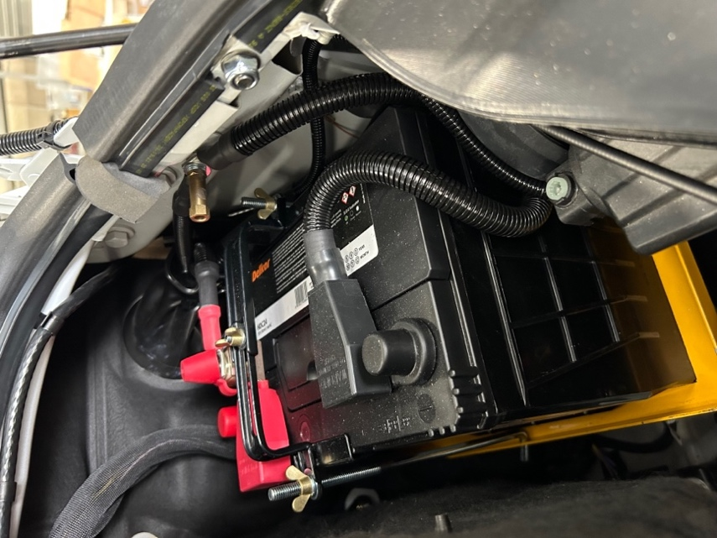
2

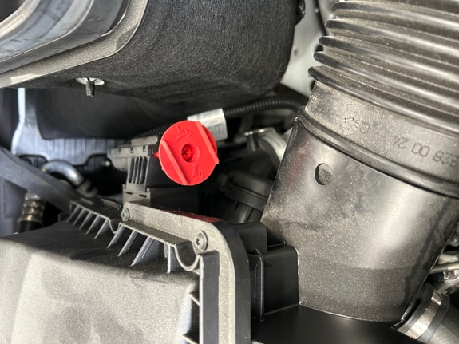

1

  - NOTE
Failure to follow this method of jump starting could result in damage to the ignition switch, fuse and relay module

Spare Wheel
The spare wheel is located underneath the rear floor of the vehicle. Please note that due to the fitment of the Self Loading Stretcher system, the spare wheel release is now only accessible from under the vehicle.
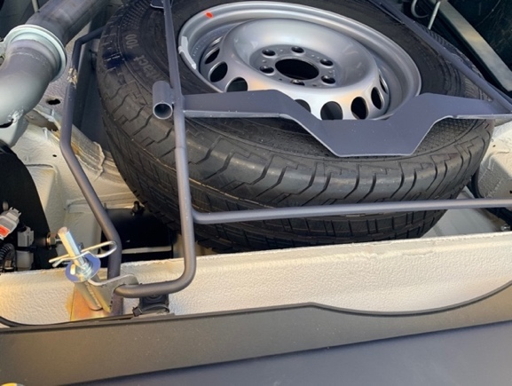
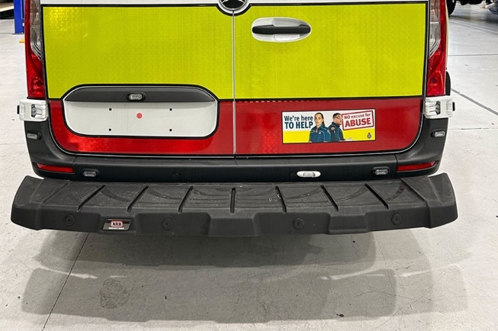
Please refer to the Mercedes Benz Vehicle Operators Manual for instructions on how to access the spare wheel, and the procedure for changing wheels.

  - NOTE
Access to the bolts mentioned in the above manual is gained by first removing the plastic grommets in the rear sill.

Remote Locking System
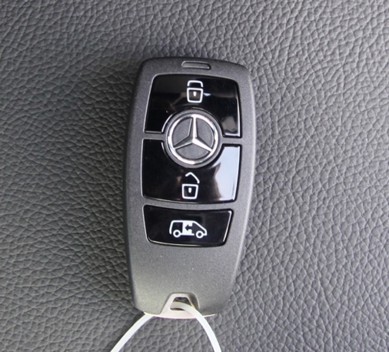
The vehicle is fitted with a central locking system for all external doors. The system has three buttons and is operated using the vehicle key as follows:
LOCK
UNLOCK
REAR DOORS
- Press the unlock button once to unlock all exterior doors.
  - The vehicle indicators will flash once.
- To lock all the doors press the lock button once.
  - The vehicle indicators will flash three times.
- To unlock the rear doors only, press the “Rear Door” button.
- Indicators will not flash if doors are open when trying to lock vehicle.

Rear Doors
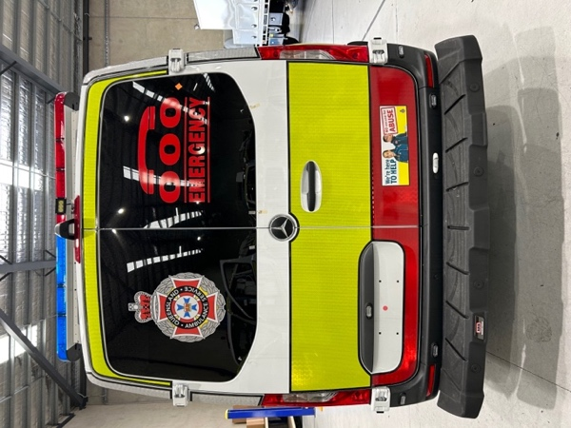
The vehicle is fitted with barn style rear doors. The driver’s side door should be opened first. Conversely the passenger side door should be closed first.
The rear doors can open fully by releasing the catches when opening the doors.

Warranty Conditions and Maintenance

Warranty
The provisions of the Mercedes-Benz warranty (3 years or 200,000km) cover the following components:
- Base vehicle
- Front and rear air-conditioning
- Central locking
- Engine immobiliser
All components manufactured and modified by SEVA are warranted against faulty workmanship and material for a period of three years or 200,000 km from the date of registration, with the exclusion of:
- Damage due to accident, misuse or alteration
- Damage or corrosion due to environment, chemical treatments or after-market products
- Damage due to insufficient or improper maintenance
The warranty is provided on the provision that any fault has not been worked on by any party other than one authorised by SEVA, or any other party under agreement by SEVA. Full details of the Warranty are available on request.
*Note that a copy of the Warranty Claim Form is included at the rear of this document. A Warranty Claim Form (see back of this Manual) must be completed and submitted to SEVA for processing and approval prior to any work commencing.

Maintenance
Maintenance services are performed at the owner’s expense. Regular servicing of the vehicle must be maintained as per the original warranty documents (received under separate cover). For more recommendations on exterior cleaning please see Section 14.4 on pg.40.

Vehicle Specifications
Engine Specifications
Model | Sprinter 419 CDI
Body Style | MWB
Engine | Diesel 2-stage turbocharged intercooled EURO 5
No. of cylinders | 6/V
Bore/stroke (mm) | 83/92
Total displacement (cc) | 2987
Rated output (kW) / (hp) @ rpm | 140 kW (190 hp) @ 3800 rpm
Max torque (Nm @ rpm) | 440 Nm @ 1400-2400 rpm
Fuel supply | Electronically Controlled Direct Injection with Common Rail (CDI)
Fuel tank capacity (litres) | Approx. 100 L
Transmission
Type | 7G-TRONIC PLUS 7-speed Automatic
Drive | Rear wheel
Weights & Capacities (kg)
Permissible front axle load | 1800
Permissible rear axle load | 2430
Gross vehicle mass (GVM) | 4050
Kerb weight | 2213
Payload capacity | 1837
Dimensions (mm)
Wheelbase | 3665
Length | 6400
Width | 2400
Height | 2620
Rear overhang | 1240
Floor loading height | 616
Distance between wheel arches | 1350
Sliding door opening (WxH) | 1300x1520
Barn door opening (WxH) | 1565x1540
Other Specifications
Turning circle (m) | 13.4
Rear axle ratio | 3.692
Rim size (inches) | 6.5J x 16 Steel Wheels
Tyre profile | 235/65 R16 C
Battery | 12V/p5 92 AGM (Absorbed Glass Mat)
Alternator | 14V/180A

Exterior Views

Front View
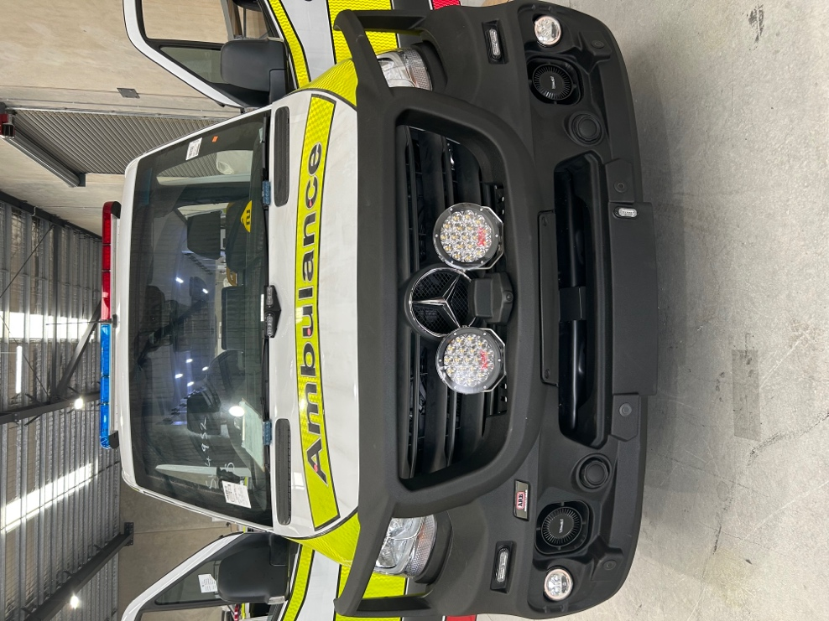
6
3
3
5
4
2
2
1
- Light bar
- Drive Lights
- Bonnet LEDs (Flashers)
- Intersection Lights
- Siren Speakers
- Front camera

Rear View
1
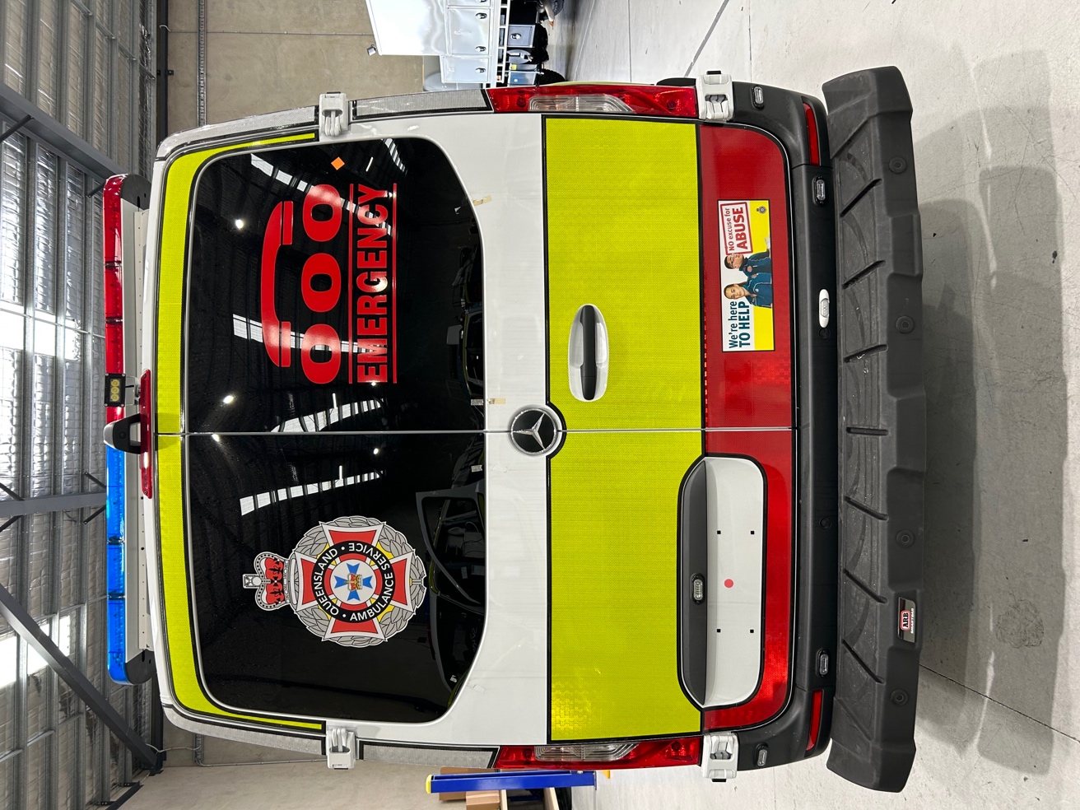
5
5
4
3
2
4
- Rear Light bar
- Rear Scene Light
- Rear View Camera
- Red and Blue Flashing LEDS in Bumper
- Amber Reverse LED Lights

Audio-Visual Warning Systems

Emergency Lighting (Exterior Layout)
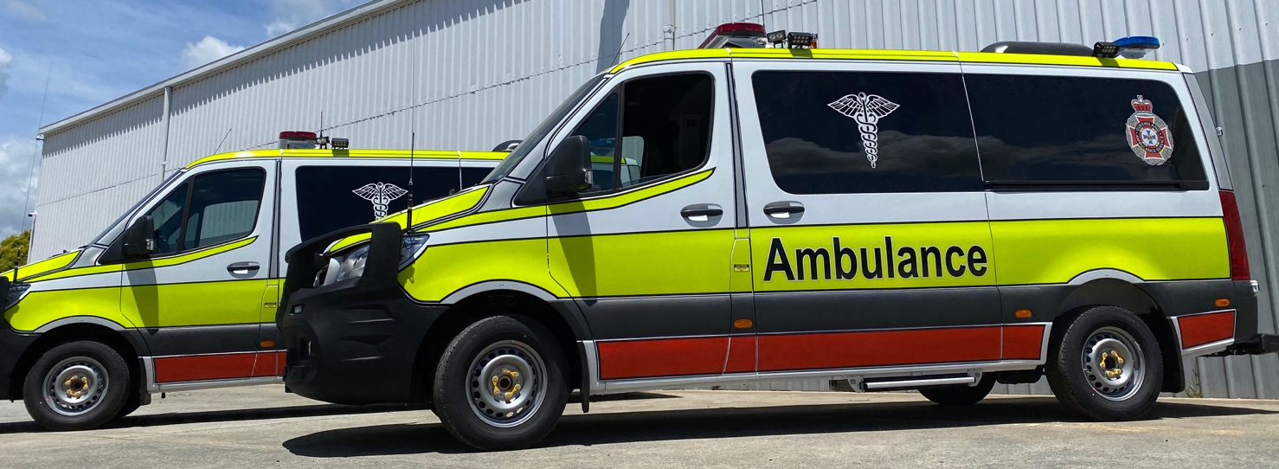

Door Ajar Warning Device
In the event of a rear or sliding door being left ajar or not properly closed, an audible alarm will sound when the ignition or master switch is activated. The alarm will cease after 5 seconds of activation.
As an added safety measure a warning light will illuminate on the main switch panel. Closing the doors will cancel the alarm and light.

Operation of Audio-Visual Warning Systems
The emergency warning lights and sirens are operated from the driver cabin main switch panel on centre console. See Section 15 and on pg.46 for more details.

Emergency Lighting
This ambulance is fitted with the latest high profile audio visual warning devices to ensure the maximum safety level for ambulance paramedics and others occupants on the road. These lights are also operated from the centre console in the driver’s compartment.
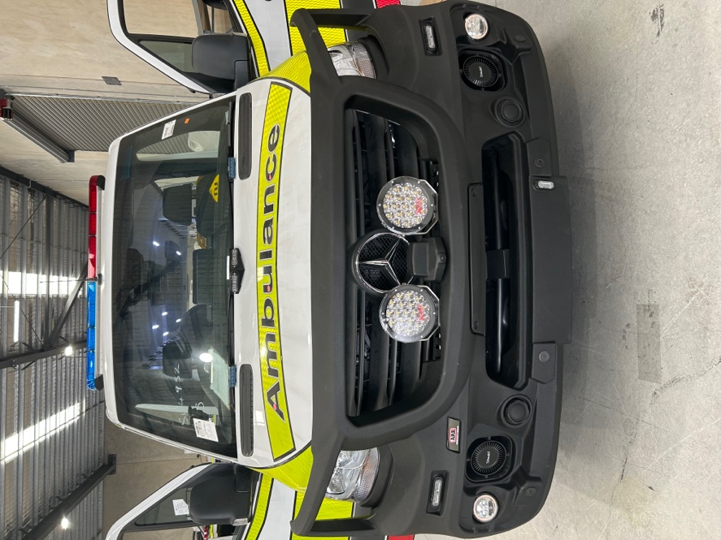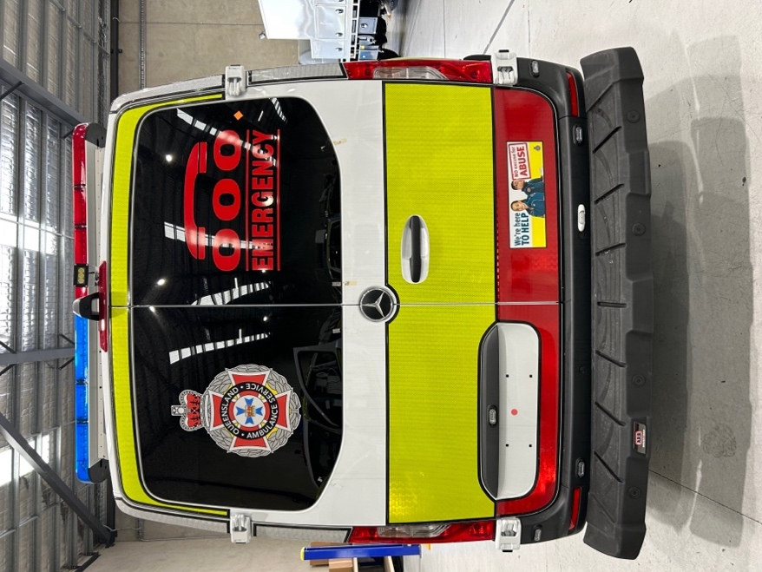
6
4
3
2
5
1
- Front LED light bar
- Bonnet LEDs
- Intersection LEDs in Smart bar
- Red and Blue Flashing LED’s in bumper
- Reverse Flashers
- Rear light bar

Stages of Emergency Lights
- Engine running, hand brake OFF and/or driving (with headlights or park lights OFF) – all emergency lights and headlight flashers will be working.
- Engine running, hand brake OFF and/or driving (with headlights or park lights ON) – all emergency lights EXCEPT headlight flashing, will be working.

Emergency Sirens
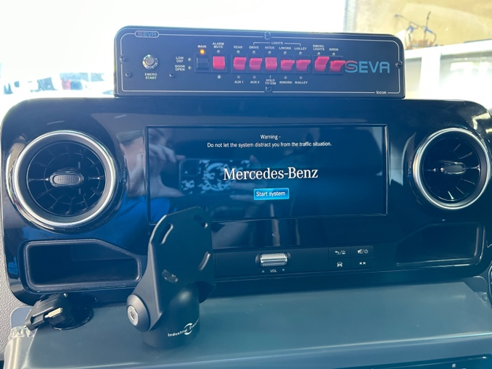
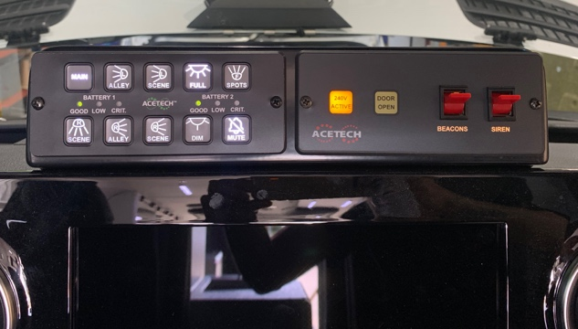
The audio devices include:
- 200 watt siren system (2 x 100 watt sirens) incorporating wail, yelp and air-horn function
- Two sirens mounted into the bull bar
- Vehicle horn
To operate, activate the “MAIN” switch – one push for on and push and hold for off.
- Flick “SIREN” toggle to turn on and again to turn off.
- the siren will only operate if the park brake disengaged
- Press the vehicle’s horn to change siren between “wail”, “yelp” and “combined wail and yelp”.
- Press vehicle horn to activate “Air Horn” function.
  - NOTE
Please ensure that the siren is not activated in confined areas such as ambulance stations or workshops without consideration for people in the near vicinity. The siren system is a “soft start” system achieving full volume after approximately 2 to 4 seconds. While siren is off or main switch is off, horn operation will be as outlined in the vehicle manual.

Conspicuity
The latest QAS Mercedes Benz Sprinter 419 CDI Ambulance incorporates highly reflective markings & striping.
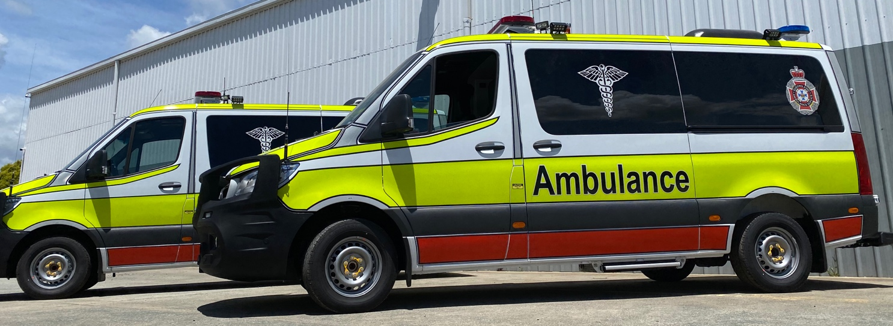

Climate Control (A/C)

Drivers Compartment Climate Control
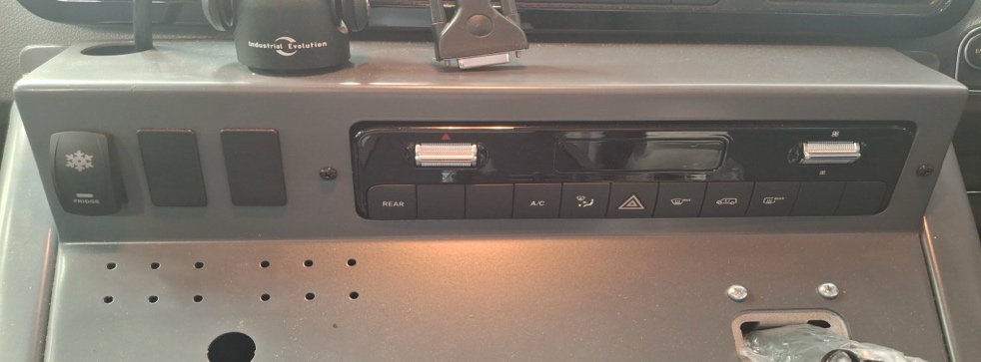
The drivers compartment A/C and heater is operated separately from the patients compartment. This system is a factory standard from Mercedes Benz. Refer to Mercedes Operators Manual for full instructions on operating front compartment controls.
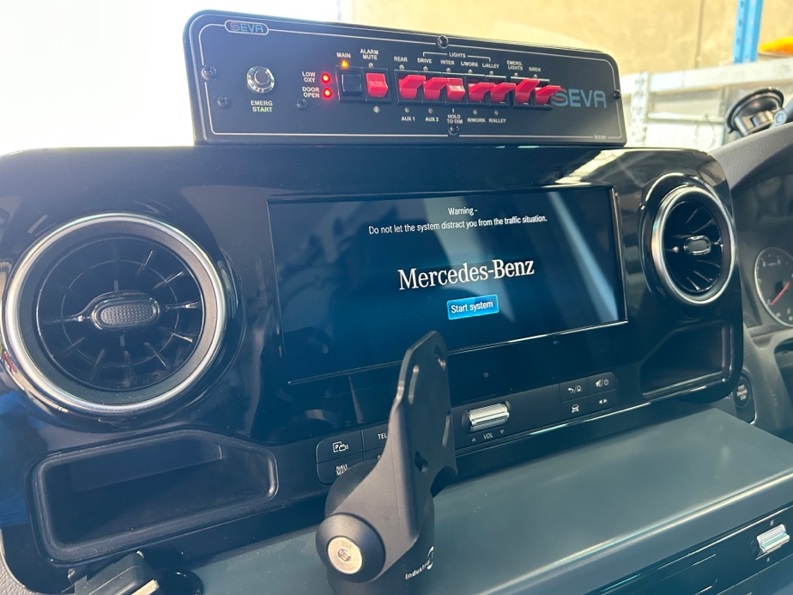

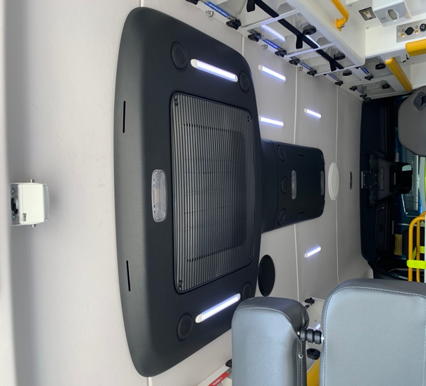
Rear Climate Control (Mercedes Roof Mounted Unit)
In Sprinter ambulances fitted with original Mercedes rear air conditioning (Black roof top pod and internal black ducted air outlets), then control of the rear air conditioning is via dash controls and rear switch panels
The rear air is ducted through the centre cowling on the ceiling. Vents can be adjusted to direct air as required.

Compartment Heater Controls and Operation
The patient compartment heater is located under the rear facing attendant’s seat which is ducted underneath the PPE Locker.
The heater is connected to the engines coolant system and provides warm air directed rearward, down the aisle of the vehicle. Since the heater is connected to the engine coolant system, the engine needs to be running for a while to give consistent warm air.
The outlet has adjustable louvers to direct airflow. The heater can be operated from the forward facing attendant’s seat. The heater speed is displayed on the forward-facing attendant’s control panel. Press once for low, again for high, and once more for off.
The rear heater is controlled via a 2 stage switch adjacent to the forward facing paramedic seat.
- Press once for slow fan speed
- Press twice for fan speed 2
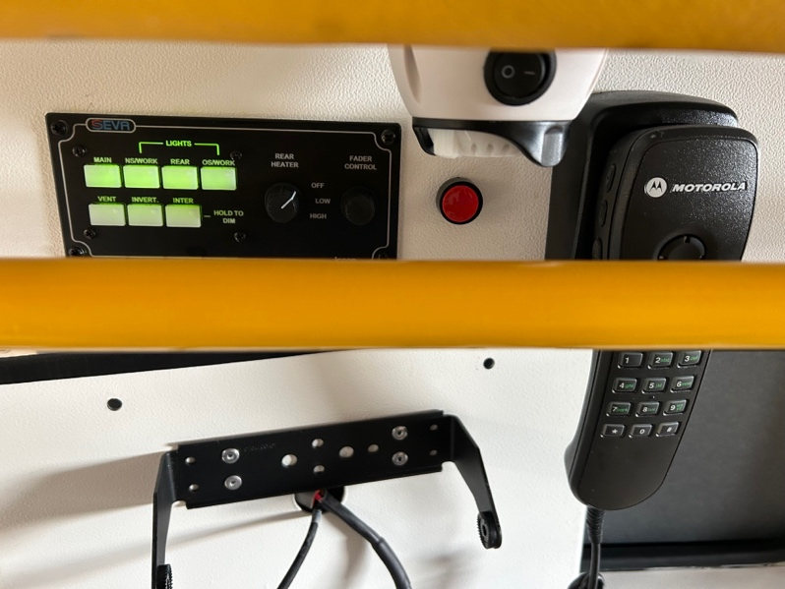
- Press again for heater fan off

Drivers Compartment Layout

Centre Console
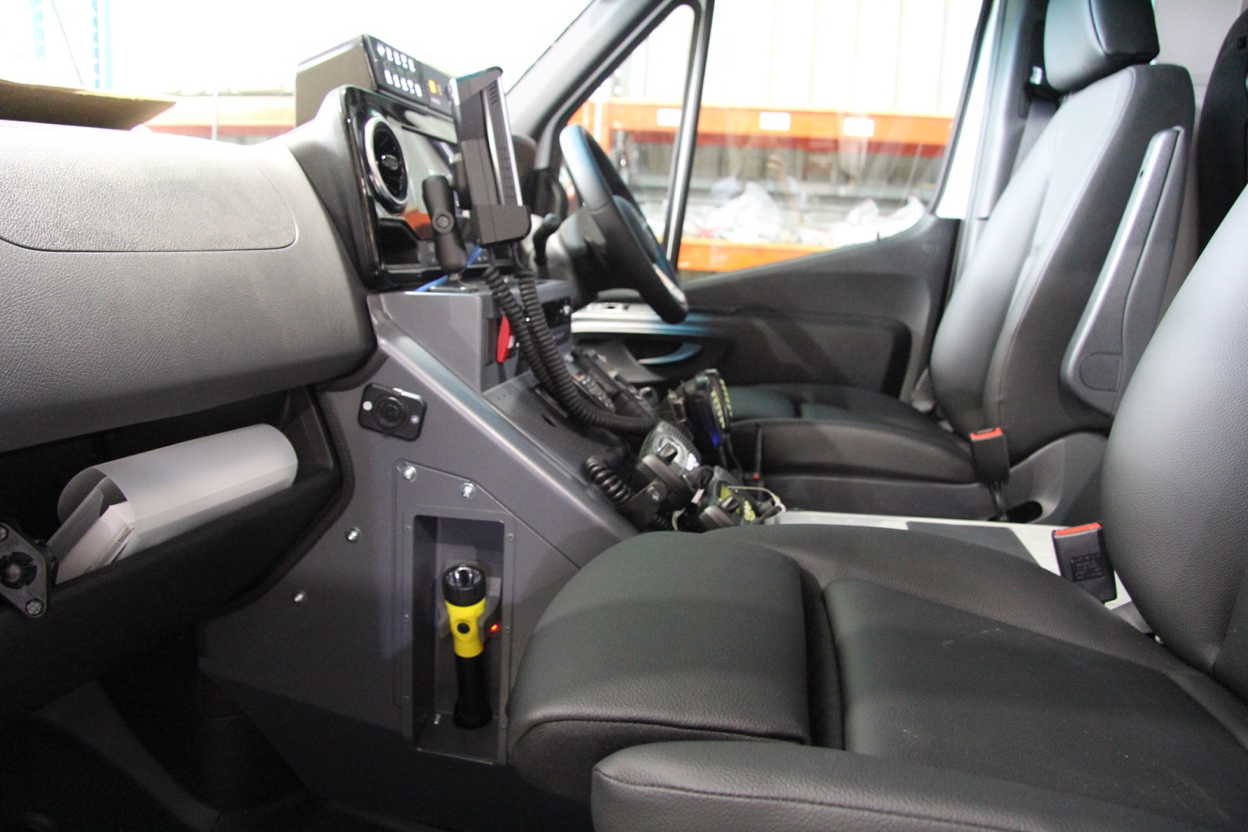

Rechargeable Torches and their Brackets
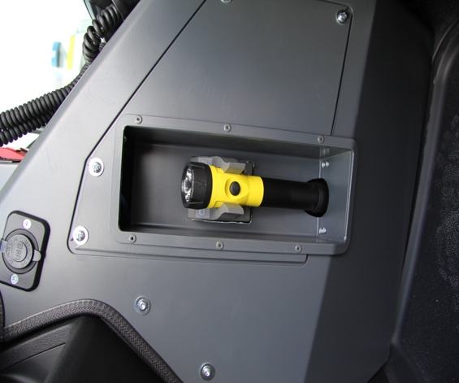
There are two rechargeable torches that are located in the cabin area of the vehicle, these are positioned either side of the centre console.

Emergency Switch Panel
The emergency switch panel is integrated into the centre console of the ambulance. This incorporates a main, scene, L/R alley, R/L scene, full, dim, F spots, mute, V active, door open, beacons, and siren switches. For more information of these switches see section 15 on pg.40.

Radio Head
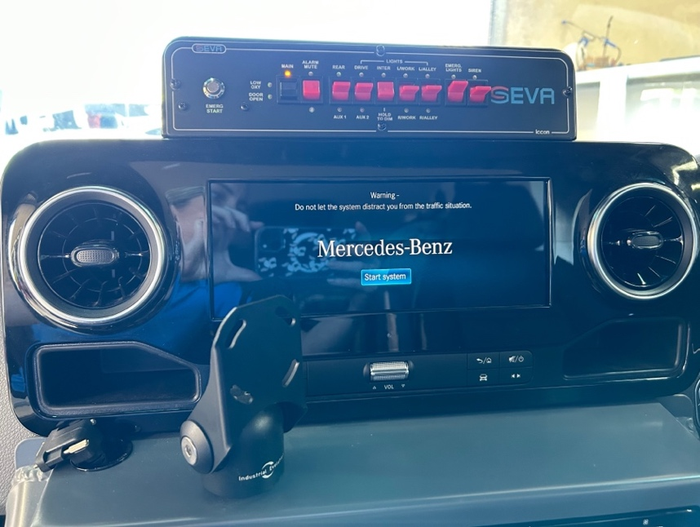
The Mercedes radio head is now re-positioned onto the centre dash and not above near light.

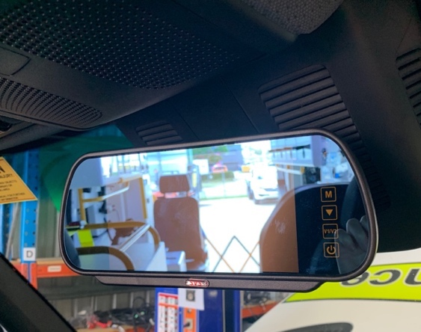
Reverse camera Monitor

Reverse Camera
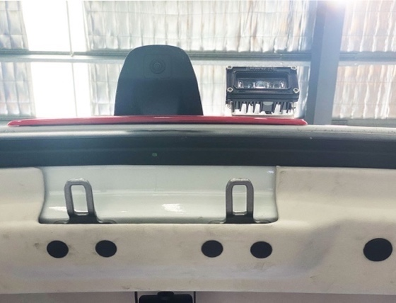
The rear view monitor is an LCD colour monitor which enables you to view objects behind the vehicle.
The device will also transmit sound from the rear of the car to the driver.
The camera is located in the centre above the rear door and should be cleaned regularly.

  - NOTE
Reversing camera system should be used as assistance to reversing only. Normal operational procedures for reversing should be adhered to.

Reversing Alarm
To ensure maximum safety for pedestrians whilst the vehicle is being reversed a visual warning system is fitted. This Operates as following:
- If the reverse gear is engaged with the ignition on. An audible warning signal is activated alerting people outside the vehicle that the ambulance is reversing.
- If the park lights or headlights are on, then the rear hazard lights will flash to alert people outside the vehicle that the ambulance is reversing. The audible alarm is deactivated in this situation.

Reversing Sensors
This ambulance is also fitted with proximity sensors and audible distance alert system wired into the reversing monitor.

Internal camera
A forward-facing internal camera is fitted above the rear barn doors to give clear vision of the patient compartment in normal and low light. The visuals are displayed on the same display as the reversing camera display.
Operation from the attendant’s seat is via a “ribbon” switch. The activation of this switch initiates the display on the rear view display screen and a green indicator light on the driver’s side of the steering column. The internal viewing camera is deactivated by re-pressing the yellow ribbon switch, noting that once activated the camera cannot be de-activated for a period of 10 second.

Cooling Compartment/Refrigerator
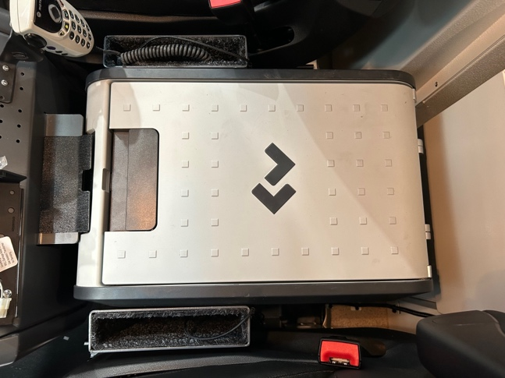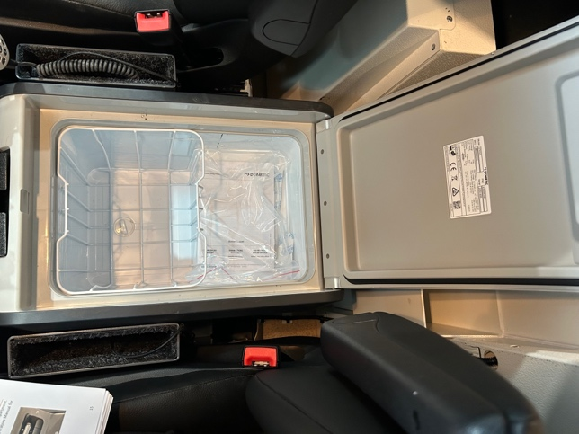
The refrigerator is a 28 litre Dometic and is located directly behind the centre console. To remove the refrigerator from the driver’s compartment:
- Unscrew three black, hand screws. Two of these are located at rear of the refrigerator on either side, and the last one is located on the passenger side of the centre console.
- Unplug all electronics
- Refrigerator can then be lifted out of position.

  - NOTE
The PPE .Locker (2) is located directly behind the fridge but CANNOT be accessed from the Drivers Compartment
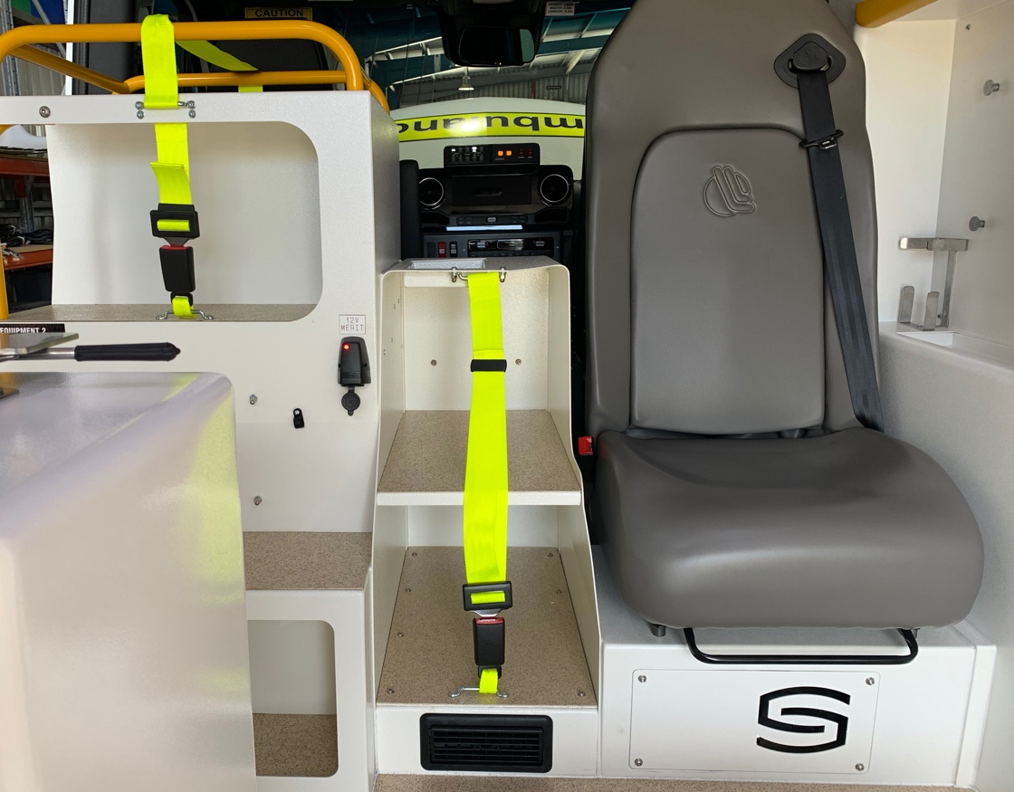

Patient Compartment layout

General Storage
- General storage cabinets are located between the driver and rear attendant seats and are accessible from outside the vehicle.
- Overhead storage is located on both the passenger and drivers of the vehicle and they have partitions on sliders to adjust sizes of storage compartments.
2
- Cardiac storage cabinets – On Passenger side of vehicle
- 12V Power outlet
- Overhead storage – on Drivers side of vehicle
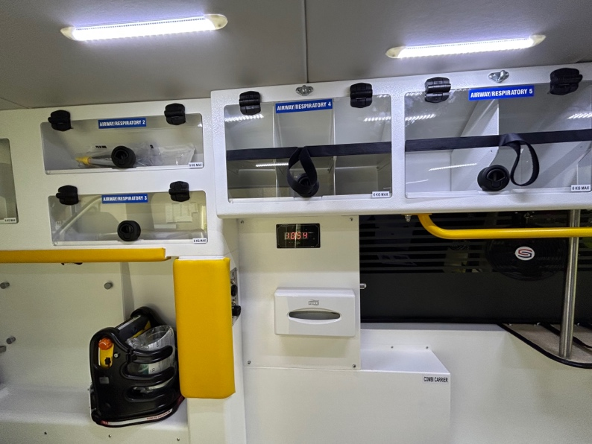
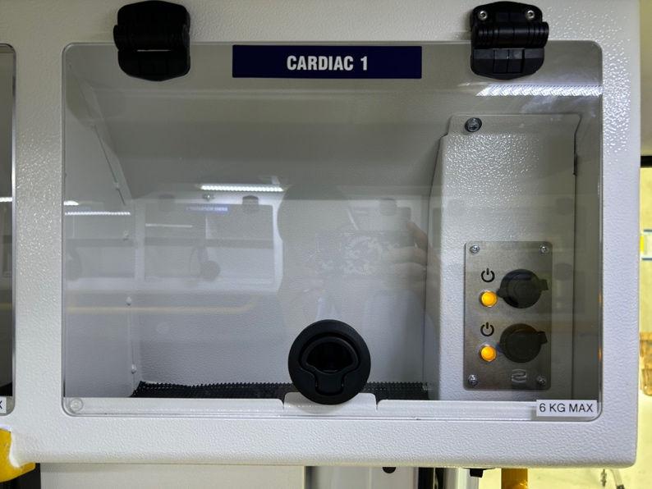
- Wall mounted airway kit storage
1
3
2
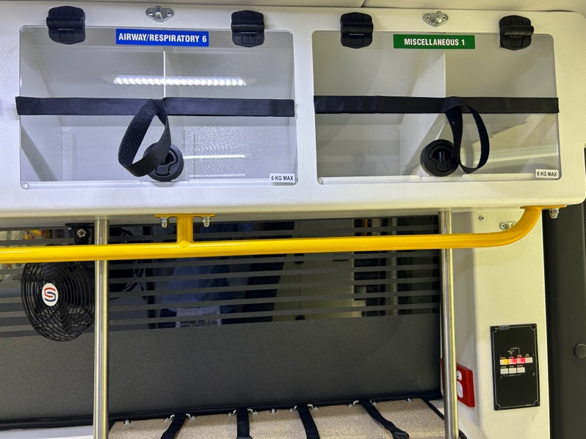
4

Overhead Drivers Side Rear– Airways
- Small equipment storage
- General airways equipment locker
- Oxygen outlet
- Clock
- Circulation fan
- Oxygen panel
- IV Hooks
7
- Battery Monitor
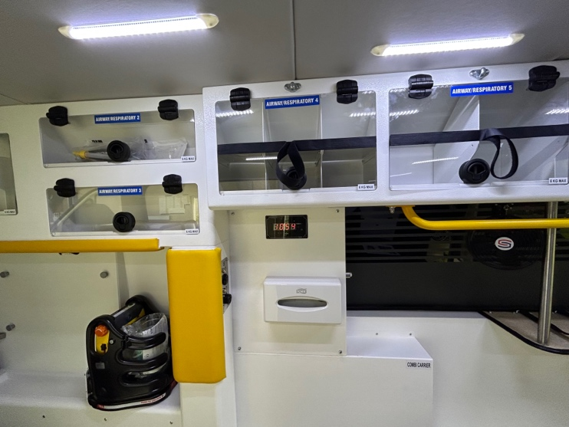
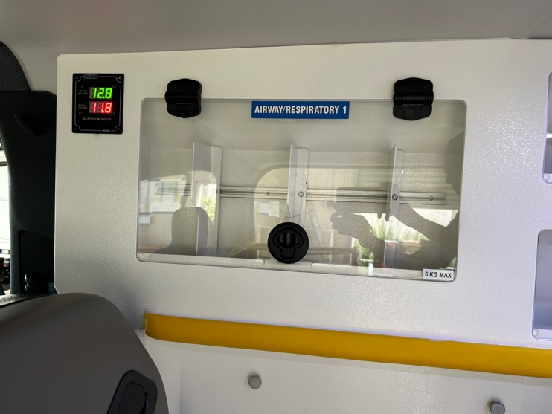
1
5
4
8
2
3
6

Rear Facing Paramedic Seat
- PPE locker (personal protection equipment)
- Heater air outlet
- Attendants tray
- Oxygen changeover valve
- Oxygen outlet
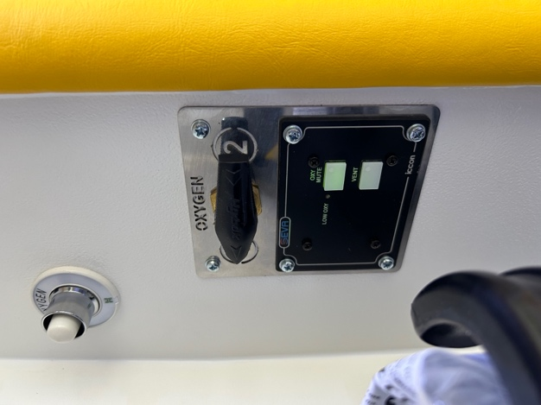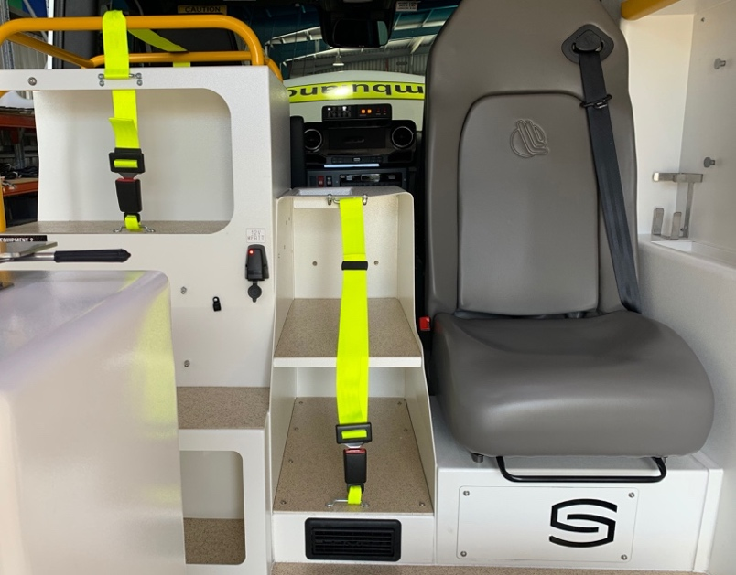
1
5
4

3
2

Passenger Side Wall Side Cabinetry
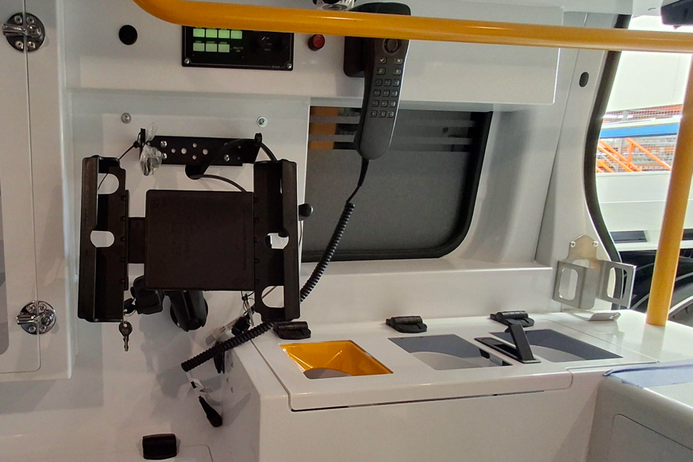
- Sharps and waste bins
- Fluids Locker
- USB Style socket
8
- Oxygen bottle locker
- Glove locker
- Communication panel (e.g., handset, radio mount, light, switch panel and duress ribbon)
1
- Splint cabinet (Storage for KED, traction splint and general splints is available in the nearside rear cabinet)
3
4&7
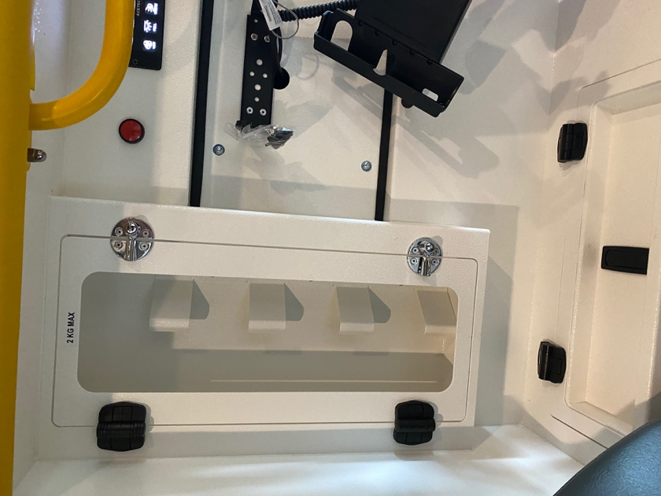
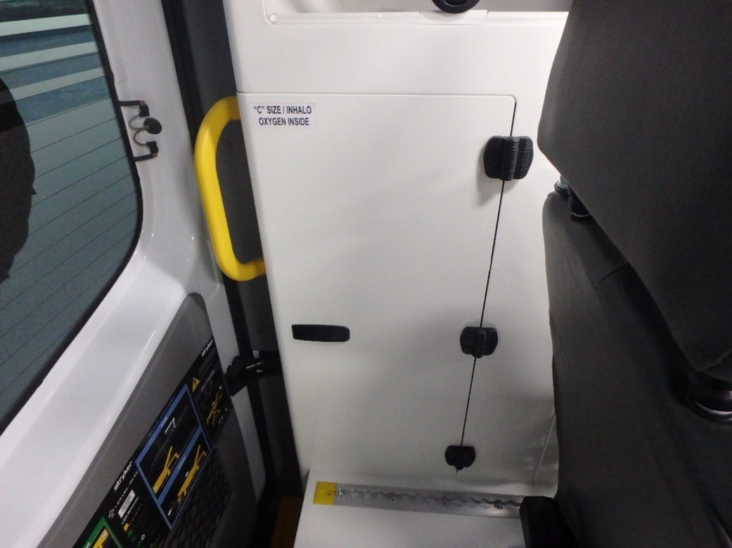
- I Pad Holder

5

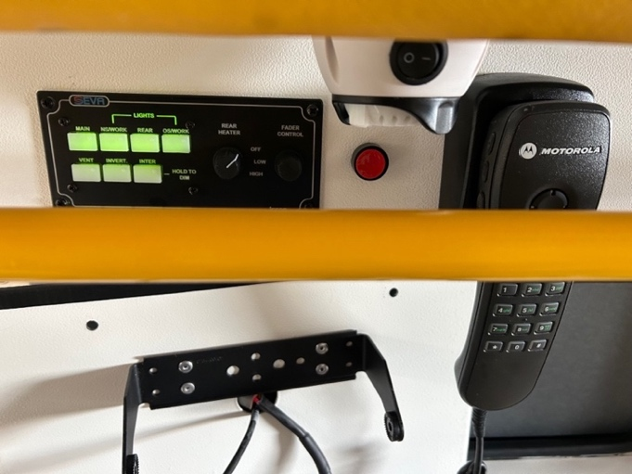
2

6

Driver’s Side Rear Cabinetry
- Combi Carrier
- Fan
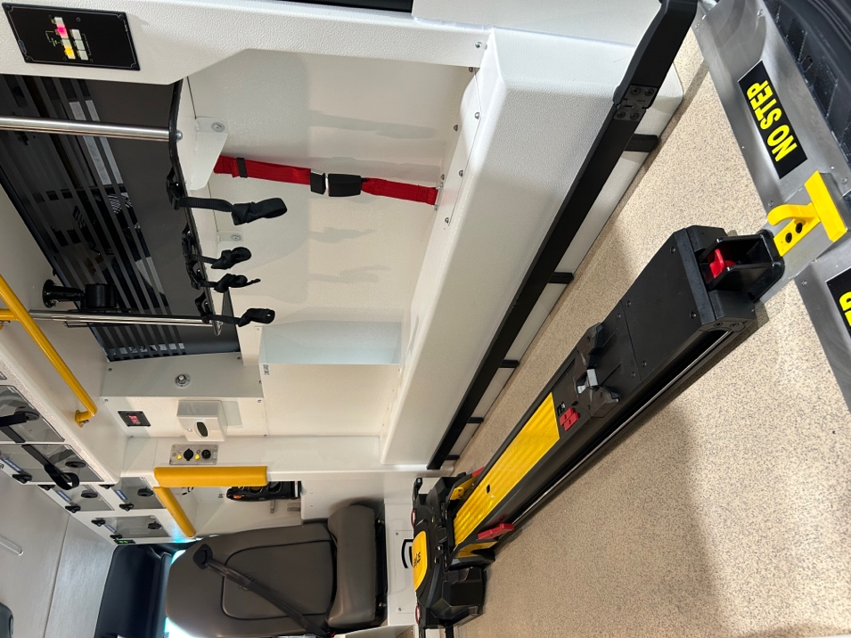
- Switch Panels
- Equipment / monitor tray with IV Poles and restraint belts
- Tissue dispenser
- Clock

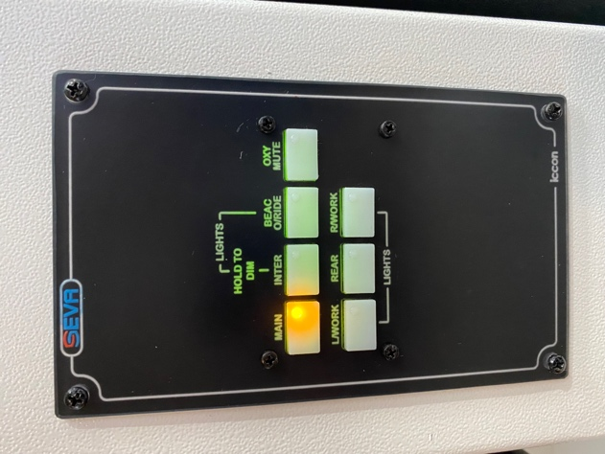
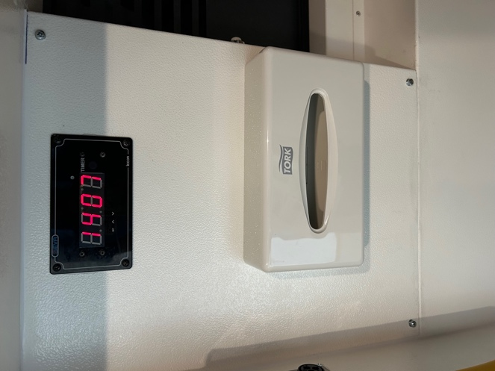
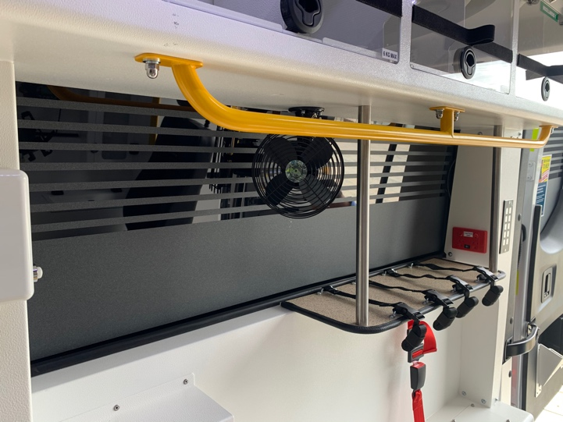
3
1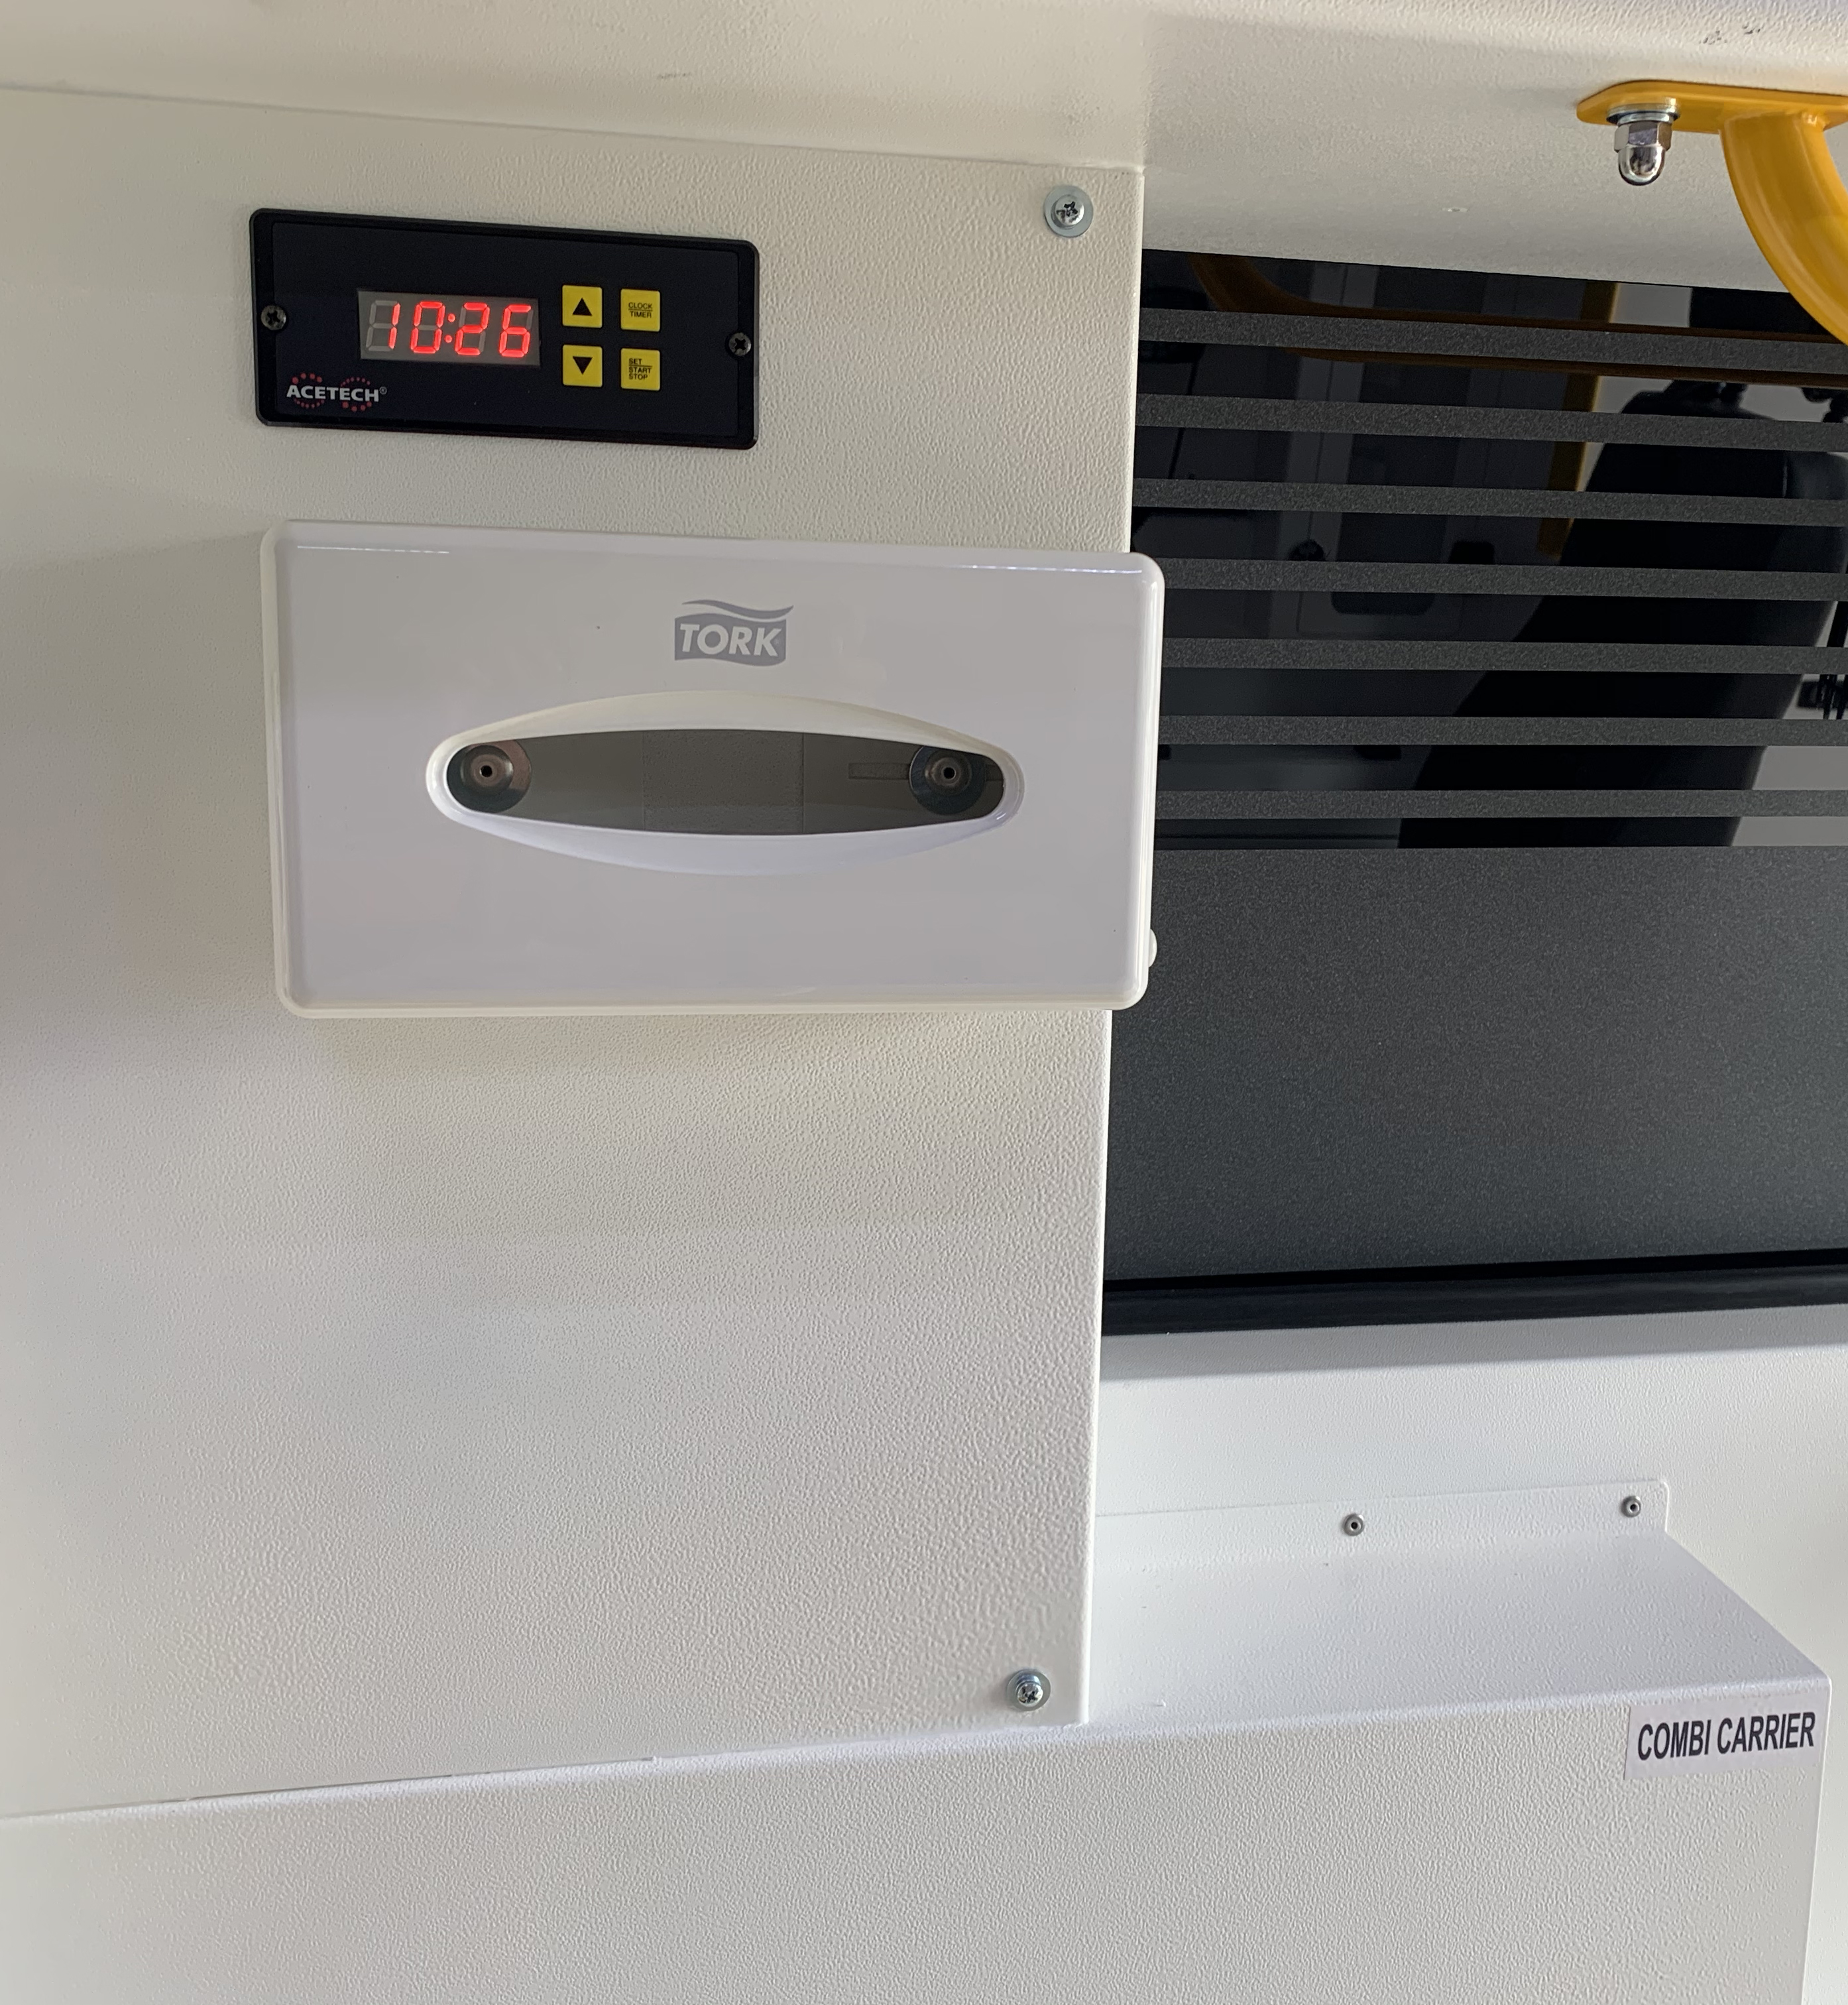
2
4
5
6

Passenger Side Sliding Door – Grab-N-Go Locker-Emergency Equipment
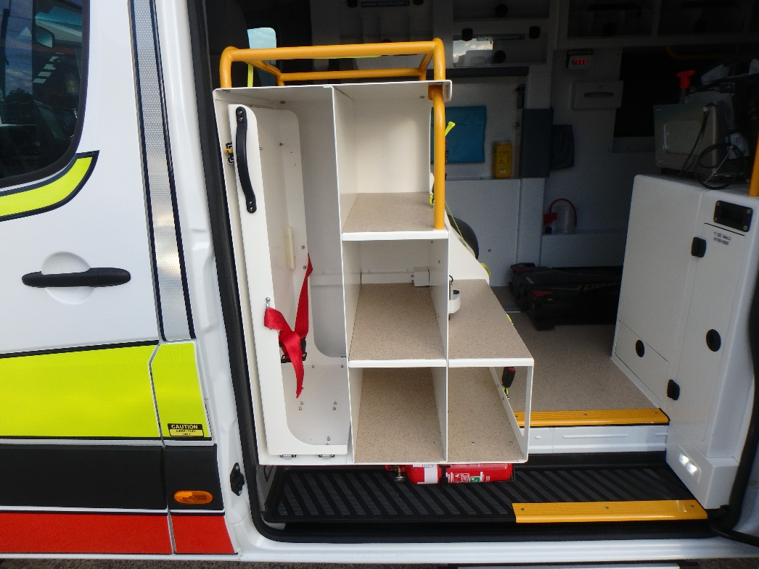
1
3
7
4
6
5
2
- Defib transport location
- Primary Response Kit (PRK)
- Resuscitation kit
- Stair chair/Carry Chair storage-slide out drawer and Patient Slide
- Minor kits (maternity and trauma packs)
- CPP Airways kit
- Fire extinguisher

Forward Facing Attendants Seat/Linen Plinth

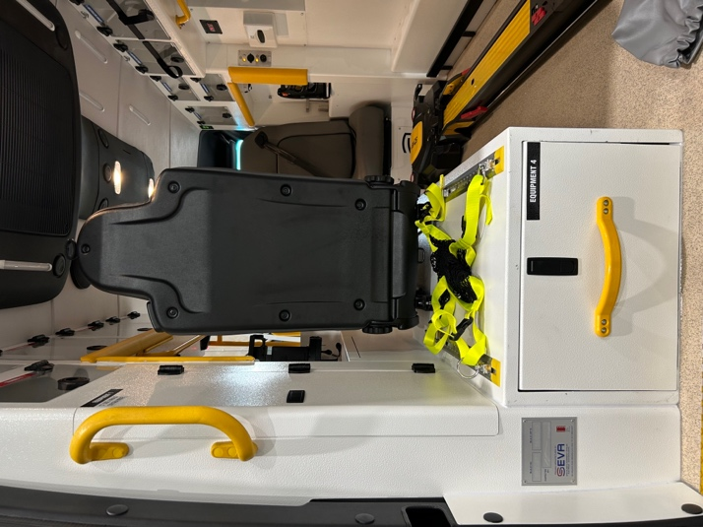
1

- Forward facing paramedic seat
4
- Linen storage drawer
- Cargo tracks
3
- Child restraint anchor point
2

Workstation
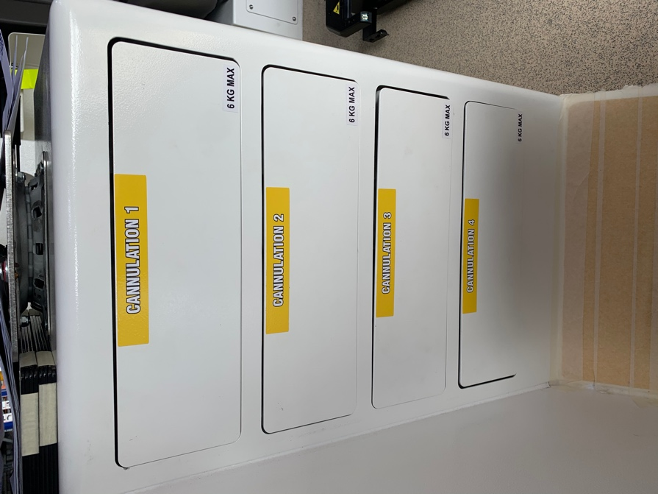
The workstation is located in front of the forward facing paramedic seat. This cabinet has 4 drawers that pull out for consumables and drugs. These are push/open draw systems.
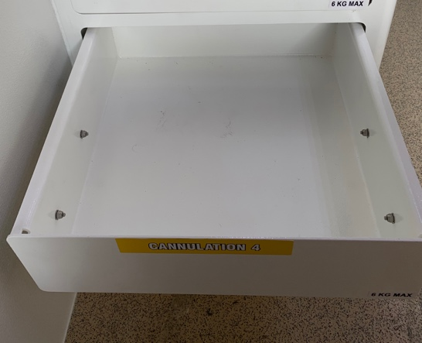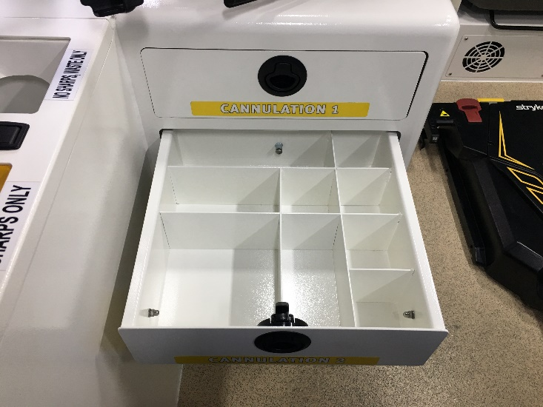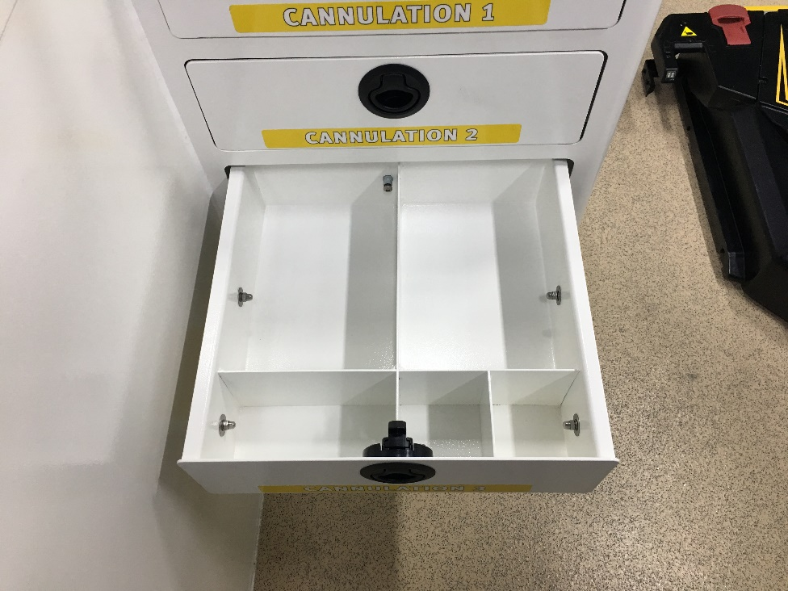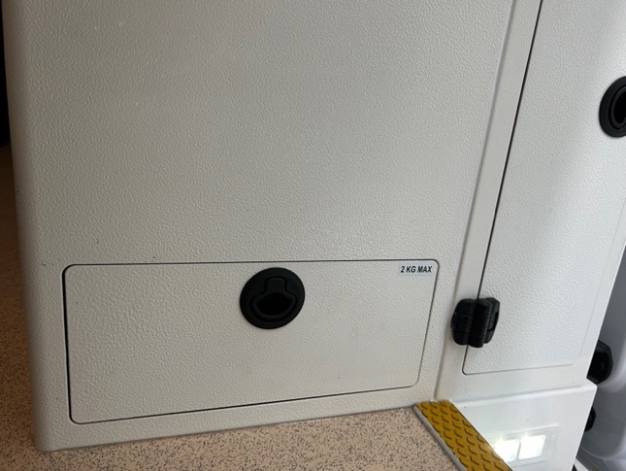

- The First draw for general storage.
- The 2nd, 3rd & 4th drawers of the workstation are fitted with dividers for consumables and drugs.
- The rear drawer is located behind the workstation and can be located from the passenger side door. This drawer is a larger, but does not contain dividers.
- The rotator on the top of the work station houses the Defib “cage” and defib/monitor. The release handle for the rotator is located as pictured. Pull to rotate the monitor.

Equipment Locations

Drivers compartment

Refrigerator
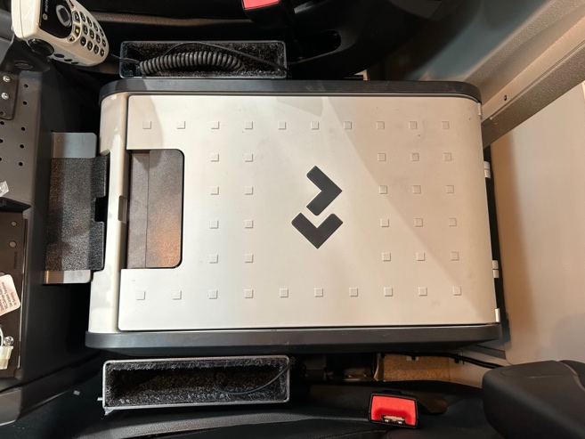
The refrigerator is a DOMETIC and is located behind the centre console in the driver’s compartment. For full instructions to operate this unit see the DOMETIC user’s manual.
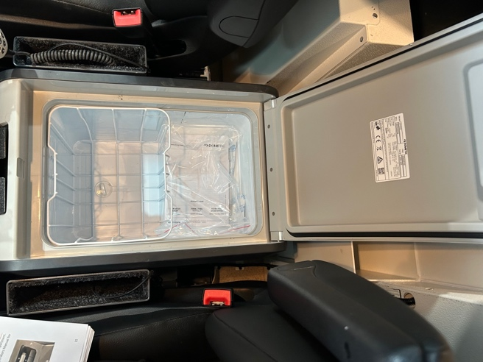

LED Torches, Switch Panel and Radio speaker
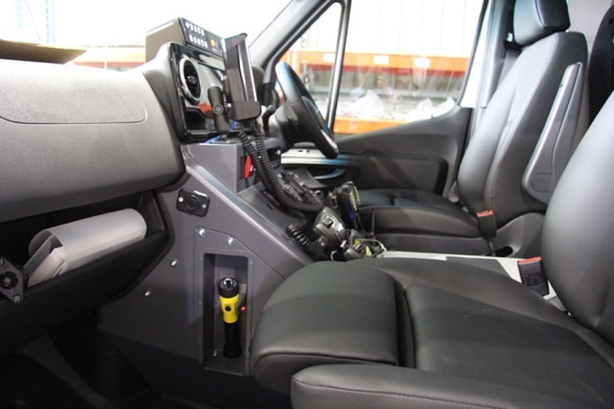
Portable radio storage is located in the centre console. Two torch holders are located on the co-driver’s side of the centre console. The switch panel is located on the top of the centre console and can be accessed by both the driver and co-driver.
Main switch Panel Panelwitch Panel
Torch holders on either side assessable for the driver and passenger.

iPads
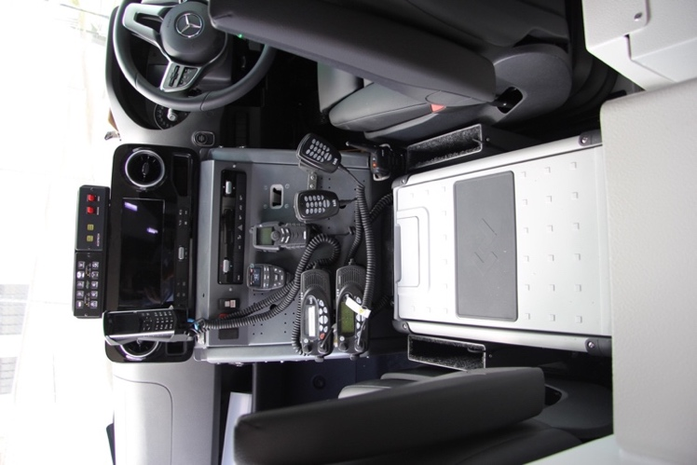
The iPads are located on both the driver’s and co-driver’s side next to the fridge. They have charging cords/ports attached.

Ipad holders plus charging ports for both passenger and driver.

Patients compartment

Patient compartment switch panels – Forward facing attendant switch panel, rear facing attendant switch panel, rear entry door switch panel
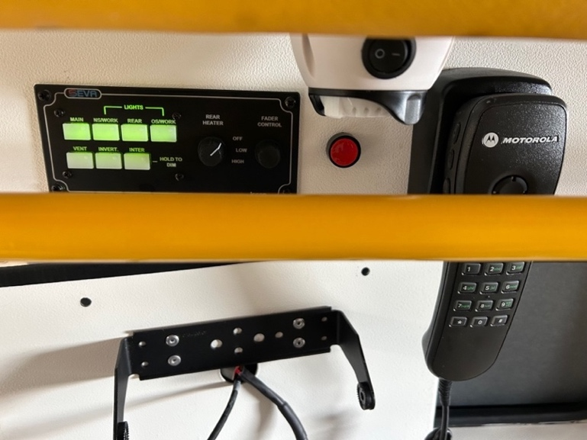
Forward facing attendant switch panel operates 240v inverter, heater, vent, external scene lights and internal lighting. Control for the OEM radio volume to rear compartment, Duress switch and internal monitoring camera are also operated from the forward-facing attendant seat.

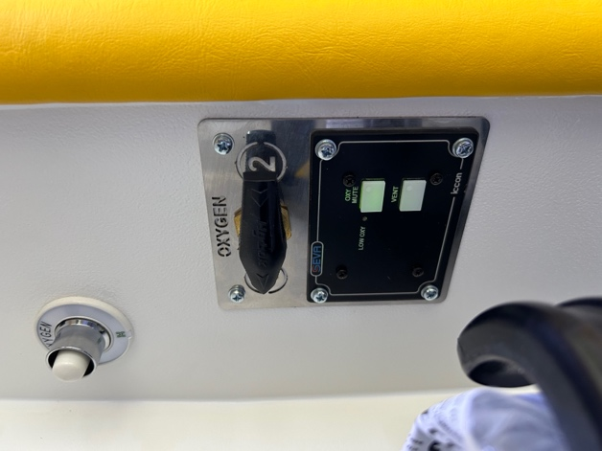
Rear facing attendant’s switch panel operates vent, suction and low oxygen alarm mute, there is also a low oxygen flashing warning light incorporated within this panel

Driver’s side rear entry door panel operates, Main, interior lights, exterior scene lights, beacon over-ride and oxygen alarm mute.

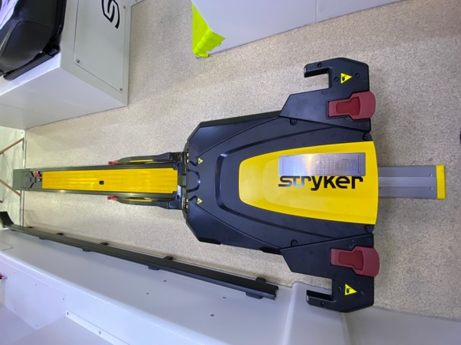
Stretcher
The stretcher is located on the driver’s side of the vehicle and has a Stryker Power Loader.

Fire Extinguisher
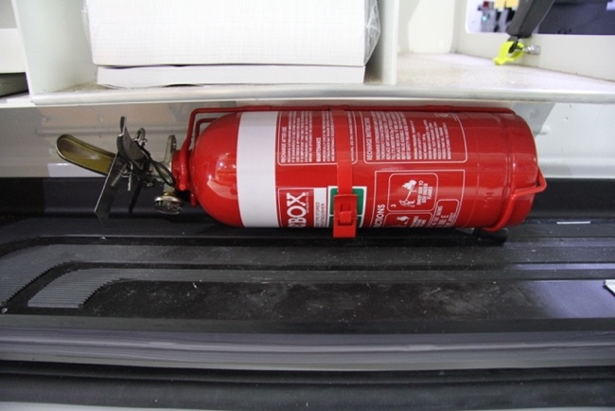
The 2 kg fire extinguisher is located in the passenger side step well directly under the grab and go locker.

Cargo Net
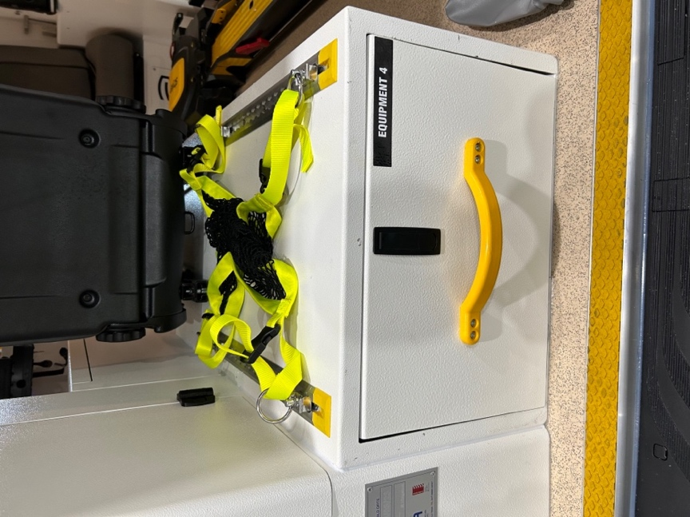
An adjustable cargo net used to secure various equipment is located on the forward facing attendants seat on top of the linen drawer. This track can be used to restrain soft packs or other items of equipment. Two belts that interface with the track are provided and should be stowed in the pouch on the wall beside the forward facing paramedic seat.

Linen Locker
A linen locker is located under the forward-facing attendant seat, accessed from the rear of the cabinet via a slide-out drawer

Wall Mounted Airways Kit Storage
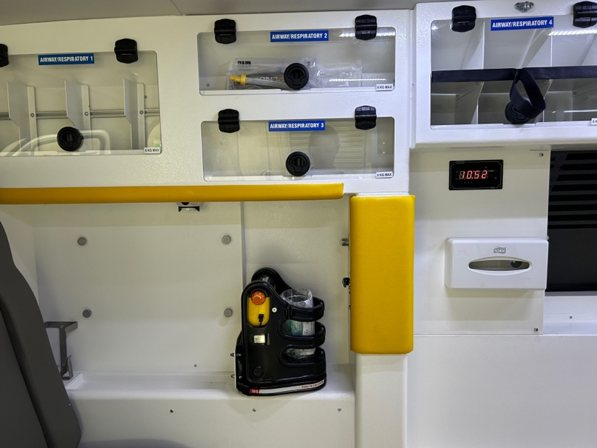
The airways kit storage is mounted directly adjacent to the rear facing attendant’s seat on the driver’s side wall.

Defibrillator and Defib Transportation location
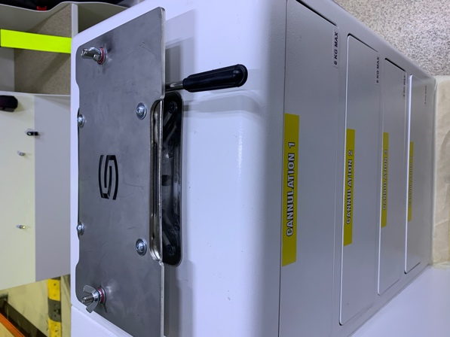
A defibrillator is mounted onto the top of the workstation with a swivel base.

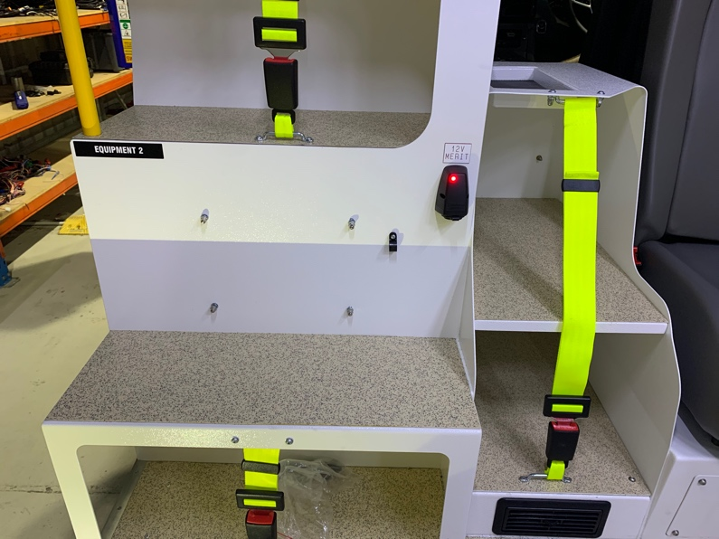
The Defib transportation location is on the rear side of the grab and go locker.

Stair Chair
The Stryker 6252 Stair Chair is located in a pull out drawer as a part of the grab and go locker.
- Release the locking catch on the top drawer slide
- Drawer will then slide out
- Again release the locking mechanism to stow the drawer
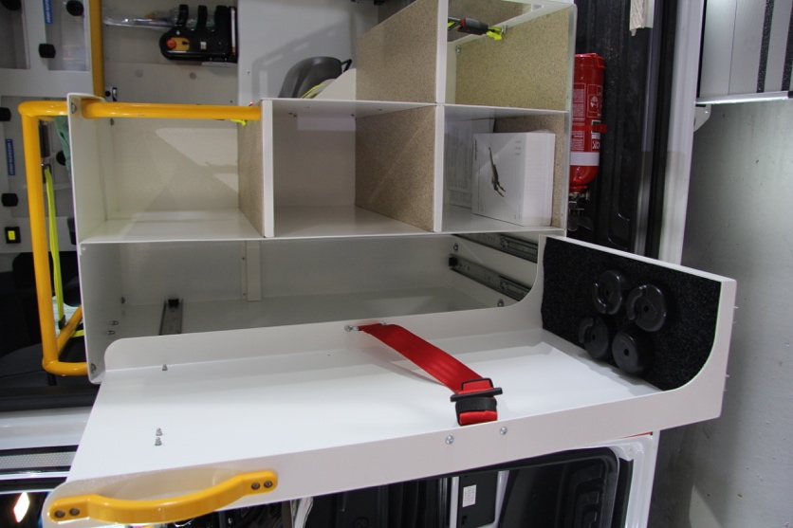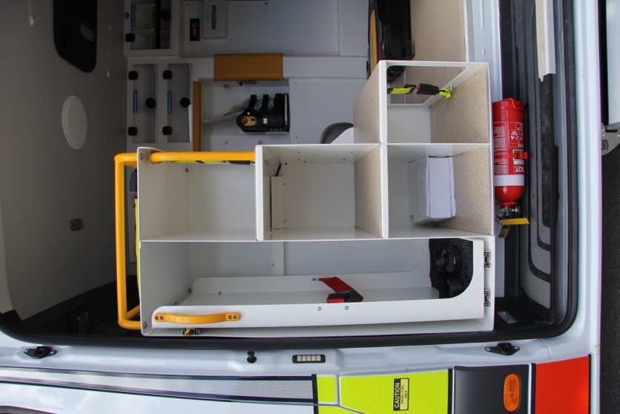

Primary Response Kit
The Primary Response Kit is located in the Grab and Go locker in the lower right section.
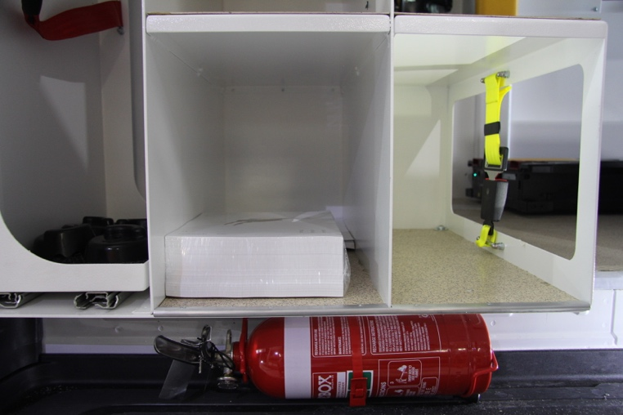

Resuscitation Kit – Resus Kit
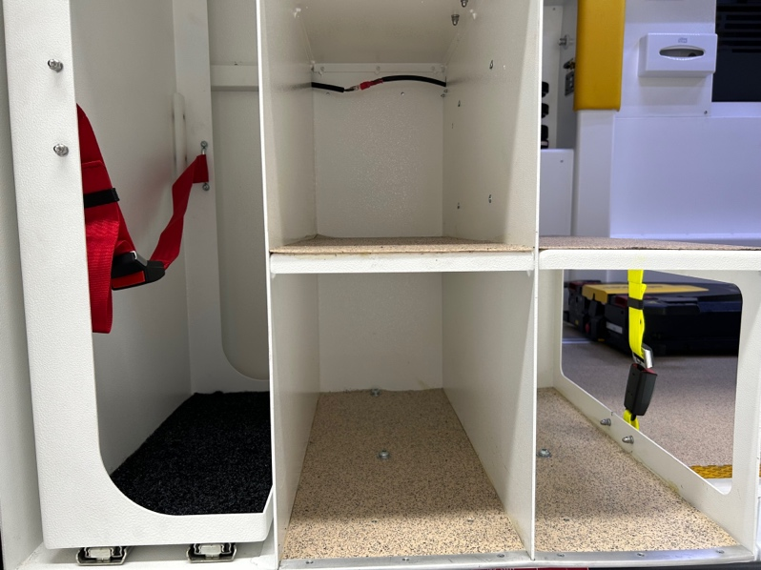
The Resuscitation Kit is located in the lower left section of the Grab and Go locker.

CPP Airway
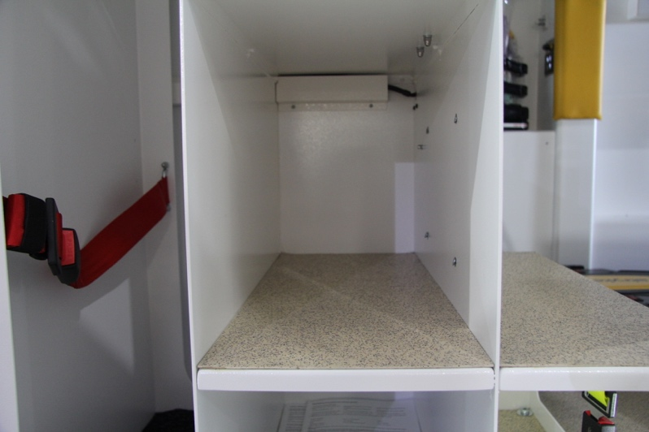
The CPP Airway kit is located in the middle section above the Resus Kit of the grab and go locker.

Minor kits – Maternity and trauma packs
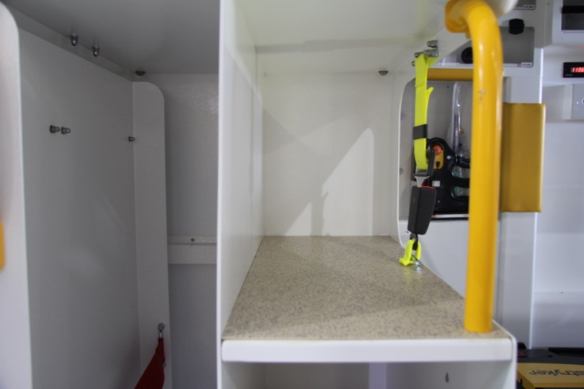
The upper most locker of the grab and go locker hold four packs and is for the maternity and trauma kits.

Monitor Shelf/ Tray and IV Poles
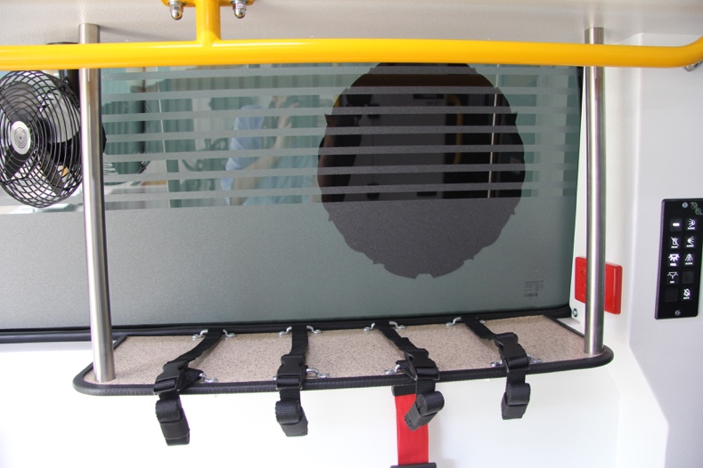
A shelf for infusion pumps and monitors is at the rear driver’s side of the vehicle. It has upright poles and retention belts for mounting equipment.
Belts are stowed in a pouch on the window sill and connect to buckles mounted on the inboard lip of the shelf.

Sharps and Waste Bins
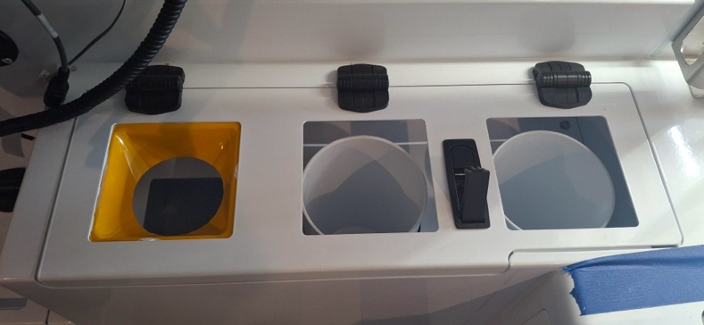
A 1 L sharps container is located in the locker below the window on the passenger side – it is marked by a yellow chute.
A clinical waste bin is located in the centre of the sharps and general waste bin.
A waste bin is located on the right.

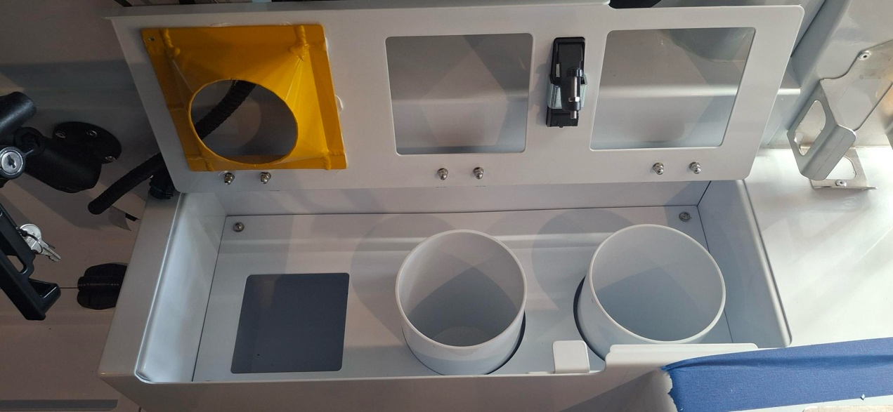
All 3 bins can be accessed for disposal of contents by releasing the latch and then lifting the lid, as pictured.

Glove Storage – Rear Compartment
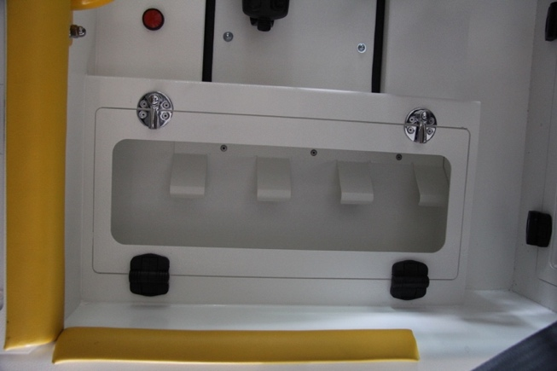
The disposable gloves is located on the passenger side of the vehicle.

Oxygen outlets and changeover valve
The two “D” size oxygen bottles are located in the driver’s side sliding door compartment. Two other “C” size bottles are located in the splints locker and in the passenger side wall side locker. For more detail on the changeover valve and oxygen outlets see section 13 on pg.37.

Charging Point
There is a 12V USB style socket located beside the oxygen panel on the driver’s side of the vehicle. The second charging point is located in the driver’s compartment to the left of the steering wheel.

12V USB Socket
socket

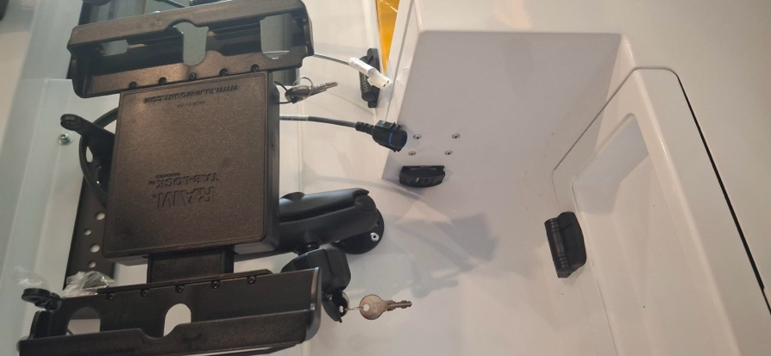

Radio Equipment Locker
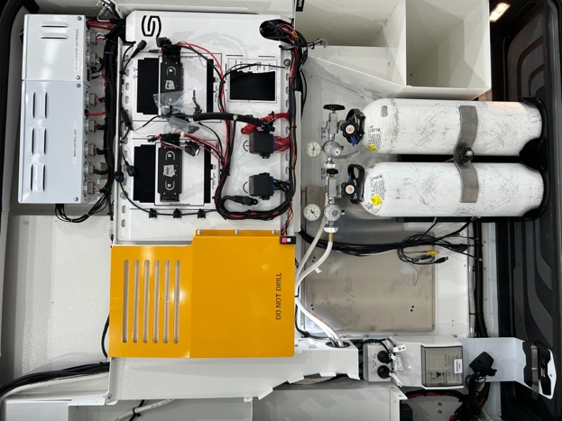
This is located in the driver’s side sliding door area. Access is restricted to service technicians.

Passenger Compartment Attendant Seats – Operation

Rearward facing Attendant Seat
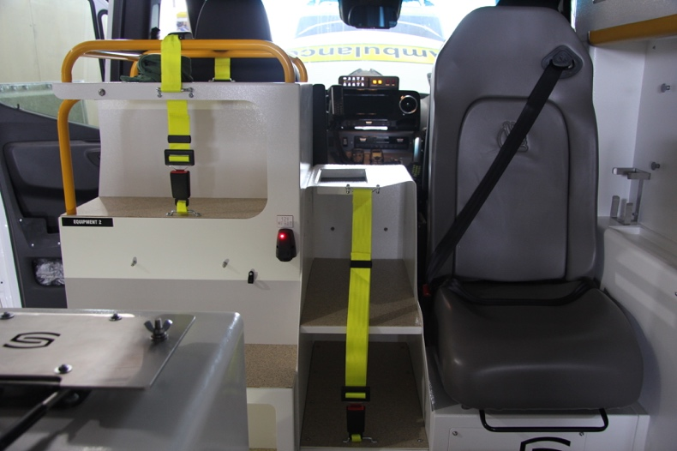
The rearward facing paramedic seat is an EVS1880 seat with integrated child restraints. Refer to instruction panel on seat for more information.

Forward Facing Attendant Seat
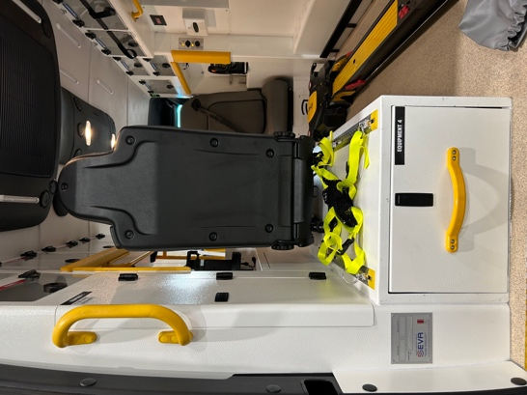
The forward facing paramedic seat is a Stratos 785 seat and has an adjustable Backrest fitted, baby capsule anchor point and integral lap sash seat belt.

Baby and child restraint anchorage point
A standard restraining anchorage is fitted to the forward facing seat. Approved child restraint devices can be fitted in accordance with the manufacturer’s instructions.

Oxygen System
The oxygen supply system is routed through the oxygen changeover valve to allow change from the empty bottle to a full bottle from the rear facing attendant’s seat.

Oxygen – cylinder storage
The oxygen locker is in the driver’s side sliding door which carries two “D” class bottles. The two “C” class bottles are in the splints locker, at the passenger side rear, and in the passenger’s side wall locker that can be accessed from the passenger’s side rear door.
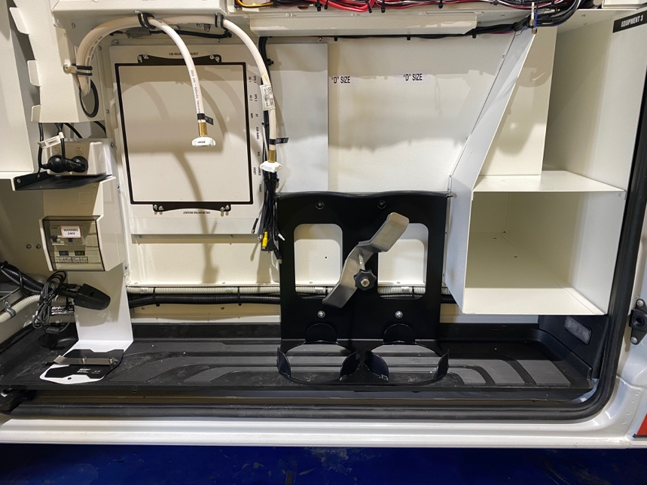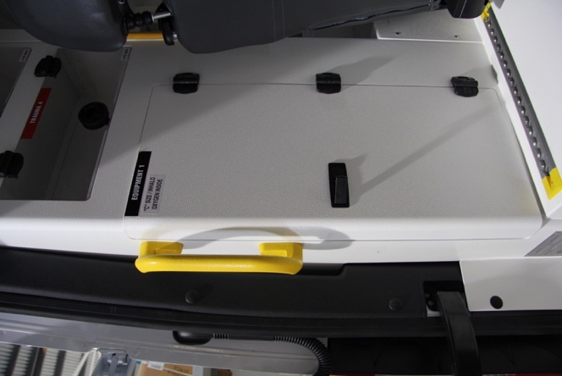

Oxy changeover valve
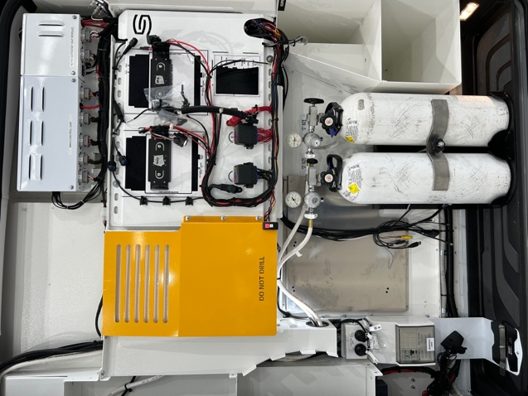
The oxygen changeover valve control panel can be access on the pillar adjacent to rear facing attendant’s seat. The valve allows the swap between the two “D” class bottles.
It has an alarm and light to indicate when the bottle being used is getting low. The mute button for this alarm can be located on the same panel.
- Oxygen changeover valve
- Alarm mute button

To replace cylinders
- Close the valve on the bottle
- Remove the regulators
- Turn the locking wheel for the retaining bar anticlockwise till it’s in the vertical position to release it
- Lift the bottle up and out of the vehicle
- Carefully lower the new full bottle into the base
- Bottle can be “rocked” from the retaining bar
- Swing retaining bar out and above the shoulders of the oxygen bottle
- Turn retaining bar horizontally until it can be rested on the shoulders of the bottle, just below the valves
- Again secure the bottles by turning the locking wheel clockwise
- Rest the regulators, then the oxygen bottle can be turned on
  - NOTE
The driver’s side sliding door will NOT close if the bottles are not secured in place. This can be prevented by making sure the restraining bar is set to pull down on the upper neck of the bottles. The bar should NOT be secured across the valve of the bottle.

Oxygen Outlets
The oxygen outlets can be located:
- On the front of the pillar next to the rear facing attendants seat on the driver’s side
- On the rear of the Oxy Panel on the driver’s Side
- On the driver’s side overhead cabinets at the rear of the vehicle (inside back doors).
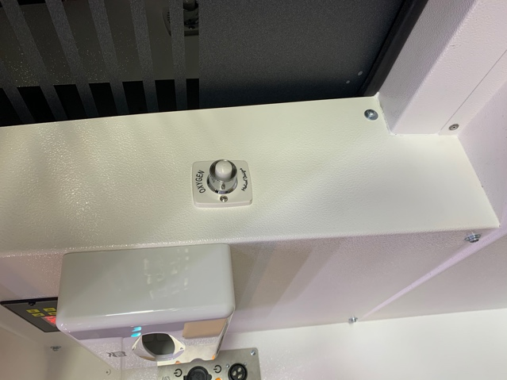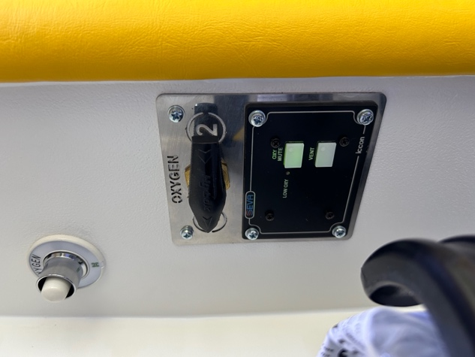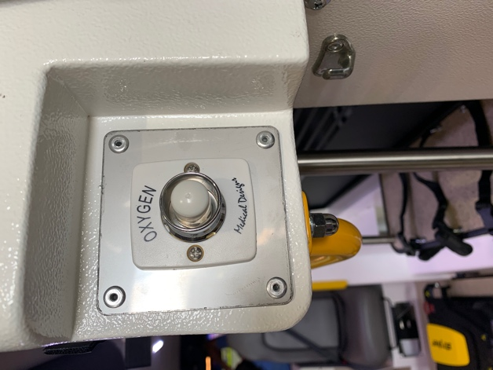
2
3
1

Other Vehicle Features

IV Hooks
The IV hooks are located on the driver’s side rear overhead lockers and on the rear driver’s side pillar adjacent to the rear doors. Hook-and-loop retention strips for IV bags have been put to the doors of these lockers.
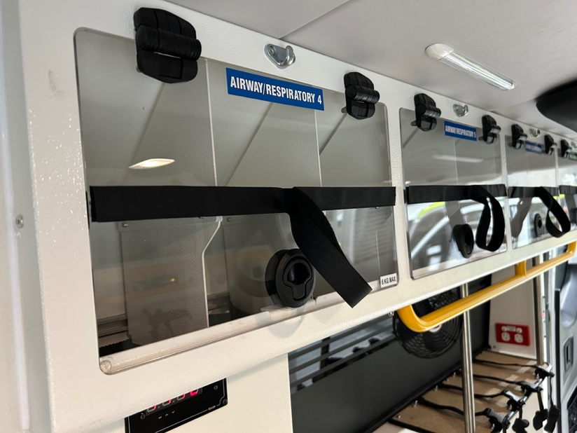fg
Above over head drivers side lockers

Fire Extinguisher
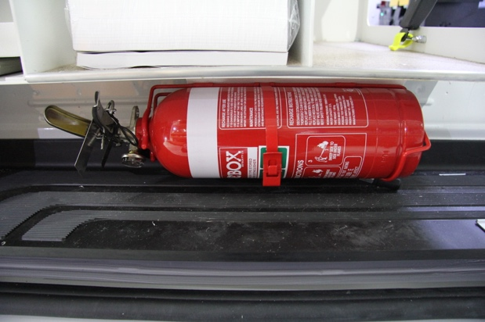
The vehicles have a 2 kg dry chemical type fire extinguisher fixed in the step well on the passenger side, below the grab and go locker.
The fire extinguisher unit has a latching bracket and is released by pulling the lever to release the fire extinguisher. The fire extinguisher is then operated by pulling the pin from the trigger, aiming the hose at the base of the fire, then depressing the trigger.

Side Steps
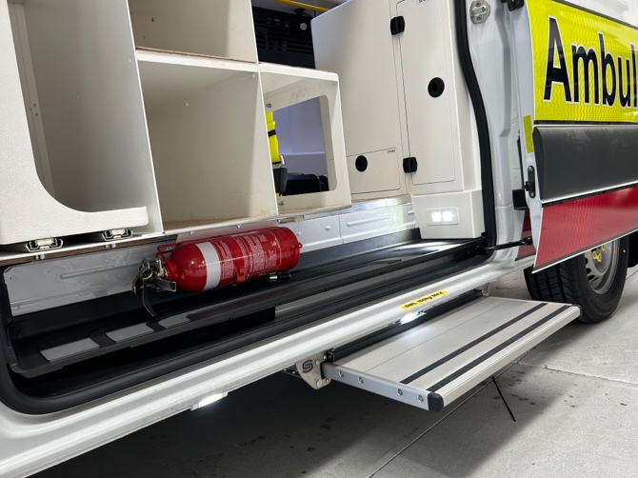
The electric side step is located externally on the passenger side sliding door. It activates when this door is opened and when the button directly above the passenger side oxygen locker is pressed. It is a 700 mm Thule Omni step which extends to 300 mm beyond the body work and has a maximum static capacity of 150 kg.
The step automatically deploys when the door is opened and the step will automatically stow when the side sliding door is closed.
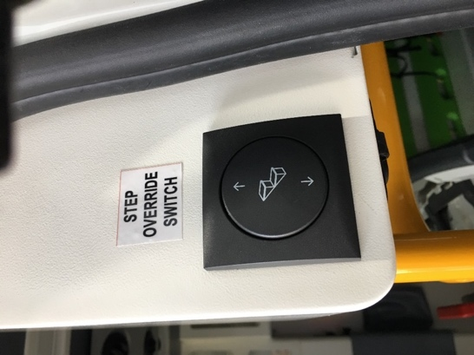
Side Step over ride button

Exterior Vehicle Cleaning
The vinyl wrap on the exterior should be cleaned with non-abrasive products and harsh chemicals should be avoided. If vehicle is scratched the marks can be hard to mask. Recommended cleaners must be wet without solvents and have a pH between 3 and 11.
The windows should not be cleaned with abrasive products.

Electrical System
- The ambulance has been fitted with the original vehicle and emergency vehicle auxiliary 12 V electrical systems.
- The vehicle has also been fitted with and inverter to provide 240 V for the biomedical equipment.
- There is also a 240 V system fitted for the battery charger

Functions not controlled by switch panels
- MDT reverse signal activates automatically when ignition is on and reverse gear selected.
- 240VAC active LED is active and buzzer is active when the 240VAC flap is open and the ignition is on.
- Fridge power is active whenever the main switch is on. Note secondary switching may be active.
- Cabin Map Light power is active whenever the main switch is on.
- Torch Chargers power is active whenever the main switch is on.
- Door Open LED will flash when the ignition is turned to on and any vehicle door is open. If the handbrake moved to the off position an audible buzzer will alert for 5 seconds.
- Oxygen Bay interior Light will be active if driver’s side sliding door is opened.
- Head light Flash module will be enabled upon activation of the Beacons switch if Main Switch on, ignition on, handbrake off and park lights off.
- Step light will be active when N/S sliding door is open
- Power outlets will be active when main switch is on.
- Rear beacon safety function will activate the rear beacons when the master switch is ON and the rear door has been opened.
- Duress alarm activate when the duress strip is pressed. The front cabin screen will activate showing the camera image from the rear of the vehicle. Activation will also trigger a 10 second lockout of the duress strip which will prevent the screen being turned off. After 10 seconds, a second activation of the duress strip will turn the front screen off.

Main Control Panel – Driver’s Compartment
The main emergency control panel is located on the top of the centre console in the driver’s compartment. It features the following switches and functions:
- A door ajar warning system that has an LED warning light, accompanied by an alarm
- An LED warning light to signal when the vehicle coolant is low
- An LED warning light to signal when engine temperature is high
- An LED warning light to signal when the 240 V power supply is connected
  - NOTE
For these alarms to work, the “MAIN” switch must be turned on with the hand brake released as if the vehicle is about to be driven off.
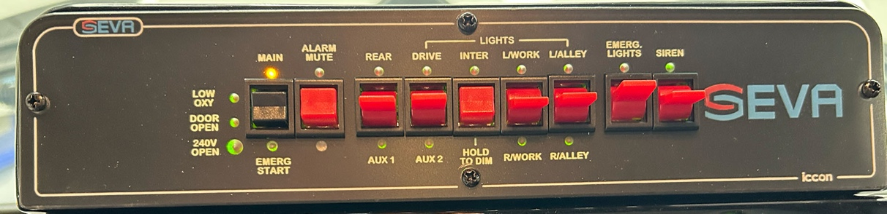

MAIN– Mains Power Switch
The “MAIN” switch is used to enable and disable the ambulance power used to operate the additional electrical features, with the exception of Drive Lights. This is done so power is not drained unnecessarily. The “MAIN” button must be pressed once to turn on and press and hold to turn off.

R SCENE
Rear Scene Switch turns on rear scene light when main is on. Rear scene switch can only be pressed if main is on and the vehicle is <40 kph. Once the vehicle reaches 40 kph the switch will automatically turn off.

L/R ALLEY
Right and Left Alley Switch turns on right and left hand alley lights when main is on. Alley switches can only be pressed if main is on and the vehicle is <40kph. Once the vehicle reaches 40 kph the switch will automatically turn off.

R/L SCENE
Right and Left Scene Switch turns on respective scene lights when main is on. Scene switches can only be pressed if main is on and the vehicle is <40kph. Once the vehicle reaches 40 kph the switch will automatically turn off.

FULL
Interior FULL switch turns on the interior lights to the full setting. The main switch must be on to enable this switch. Press again to turn off.

DIM
Interior dim switch turns on the interior lights to the dim setting. The main switch must be on to enable this switch. Press again to turn off.

F SPOTS
Drive switch turns on the vehicles drive lights (Spot Lights). Once pressed, the drive lights will be powered upon activation of the OEM vehicles high beam.

MUTE
Oxy Buzzer Mute Switch will be enabled when the main switch is on and the low O₂ alarm is active. Pressing the oxy buzzer mute switch will mute the oxy low alarm until the ignition is cycled from Off to on.

240 V ACTIVE
The 240V active indicator will be flashing and buzzer active when the 240V flap is open and the ignition is turned on.

DOOR OPEN
Door open indicator will flash when the ignition is turned to on and any vehicle door is open. If the handbrake moved to the inactive position an audible buzzer will alert for 10 seconds.

BEACONS
Beacons toggle switch will activate the vehicles emergency lighting systems. This includes all light bars and bumper emergency lights. Additionally the head light flasher module is activated by the beacon toggle switch. However for head light flashers to be active, the ignition must be on, handbrake off and headlights off.

SIREN
Siren toggle switch will activate the vehicles emergency sound system. The system will only be active if the main switch is on, ignition on and handbrake is off.
- Push the toggle switch down to turn sirens on
- Push the toggle switch up to turn sirens off
- To change between “wail” and “yelp”, press horn down once
- The vehicle air horn is activated by holding horn down
  - NOTE
If siren is off, normal horn operation instruction can be found in the Mercedes Benz operation manual

Driver Panel LEDs
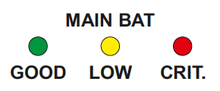
Main battery indicator LED is steady green when main battery is good (above 11.5 volts), low when below 11.5 volts and red when voltage drops below 10.5 Volts
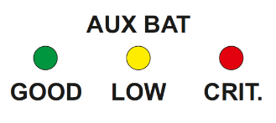
Auxiliary battery indicator LED is steady green when main battery is good (above 11.5 volts), low when below 11.5 volts and red when voltage drops below 10.5 Volts.

EMERG START – Auxiliary battery
The “EMERG START” button is for the emergency start of the vehicle and is operated by pressing down this button and engaging the ignition key. This operation combines the auxiliary and original battery to assist in starting the vehicle when the original battery is flat.

EMERG LIGHT
The “EMERG LIGHT” switch activates all the external emergency lights on the vehicle. This includes the emergency light bar and the external emergency warning lights.
When the toggle switch I in the downward position, all emergency lights are activated including all lights on the light bar, all rear emergency warning lights and front LED warning lights. For more information on these lights to refer to section 7.4.1 on pg.13.

Patient Compartment – Drivers side rear pillar switch panel
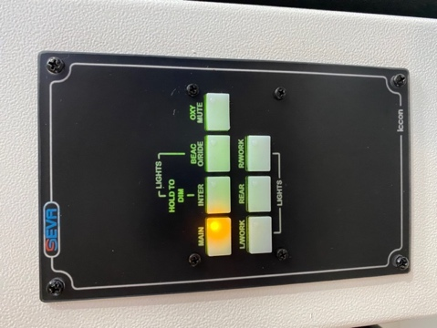

MAIN
Main Switch enables switching conditions on all panels except Drive Lights. When activated, also enables power to outlets, fridge and torch chargers. To activate Main, press the switch once. To turn off, press and hold until a single “Beep” is heard.

R/L and REAR SCENE
Scene Switches turns on respective work light when Main is on. Work switch can only be pressed if Main is on and the vehicle is <40 kph. Once the vehicle reaches 40 kph the switch will automatically turn off.

RIDE
Beacon O/Ride Switch is enabled by Main being on and rear door being open. When pressed this switch will disable the rear light bar and bumper LEDS on the vehicle. The switch is automatically turned off when the rear door is closed.

FULL
Interior Full Switch turns on the interior lights to the Full setting. The Main switch must be on to enable this switch. Press again to turn off.

DIM
Interior Dim Switch turns on the interior lights to the Dim setting. The Main switch must be on to enable this switch. Press again to turn off.

MUTE
Oxy Buzzer Mute Switch will be enabled when the main switch is on and the Low O₂ alarm is Active. Pressing the Oxy Buzzer Mute Switch will mute the Oxy Low alarm until the ignition is cycled from Off to on.

MUTE
Oxy Buzzer Mute Switch will be enabled when the Main Switch is on and the Low O₂ Alarm is active. Pressing the Oxy Buzzer Mute Switch will mute the Oxy Low alarm until the ignition is cycled from Off to on.

SUCTION
Suction Switch is enabled by having the main switch on. When activated, suction will be switched on.

LOW
Low Oxy Indicator will be lit if oxygen levels are low. When lit the system has been configured to create an audible alert. The audible alert can be temporarily muted by pressing the Oxy Buzzer Mute switch.

VENT
Vent Switch is enabled by the Main Switch. When activated, ventilation fans will be switched on.

Patient Compartment – Rear Speaker Panel
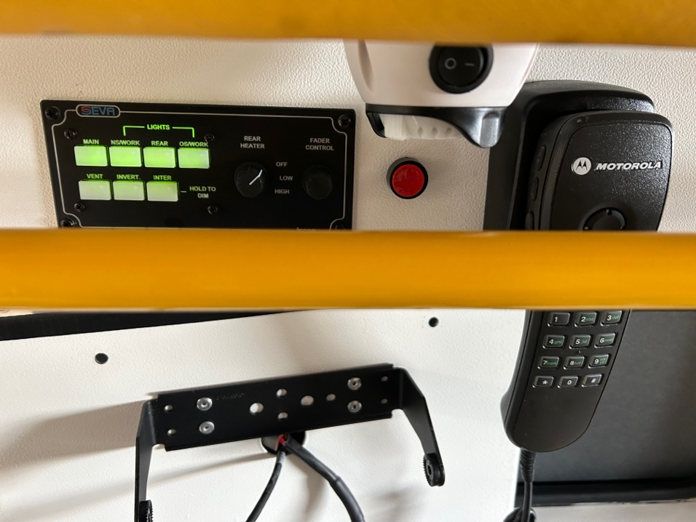

MAIN
Main Switch enables switching conditions on all panels except Drive Lights. When activated, also enables power to outlets, fridge and torch chargers. To activate Main, press the switch once. To turn off, press and hold until a single “Beep” is heard.

VENT
Vent Switch is enabled by the Main Switch. When activated, ventilation fans will be switched on.

DIM
Interior Dim Switch turns on the interior lights to the Dim setting. The Main switch must be on to enable this switch. Press again to turn off.

FULL
Interior Full Switch turns on the interior lights to the Full setting. The Main switch must be on to enable this switch. Press again to turn off.

240V INVERTER
240V Invert Switch is enabled my Main switch being on and ignition being on. When activated the vehicles 12VDC to 240VAC Inverter will be active

R/L and REAR SCENE
Scene Switches turns on respective work light when Main is on. Work switch can only be pressed if Main is on and the vehicle is <40 kph. Once the vehicle reaches 40 kph the switch will automatically turn off.

HEATER
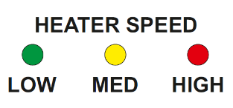
The 2 speed Rear heater Switch will be enabled when the main switch is on and the ignition is on. Pressing the Rear heater switch one will activate the heater on Low setting. Pressing it again will increase the speed to medium. Pressing the switch a third time will increase the speed to high. Finally pressing the switch one last time will turn the system off.
Displays the Heater fan speed which increases when the Heater Switch is pressed. Please note some heaters do not have a MED speed.

12V Outlets
The 12 V outlets have 3 locations in the patient compartment.
- Adjacent to the forward facing attendant’s seat on the communications panel.
- In cardiac 1 locker, located adjacent to the nearside entry door.
- On the rear face of the pillar cover located beneath the clock/timer.
- To the left and the right of centre console.
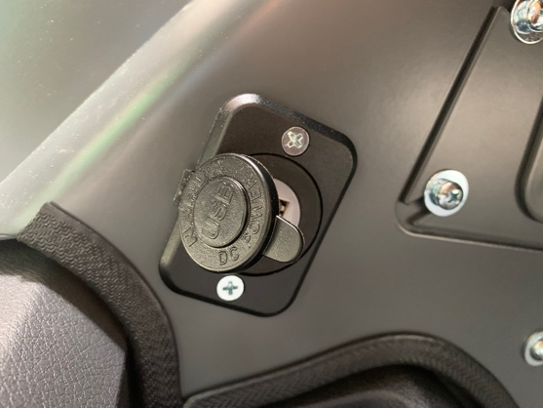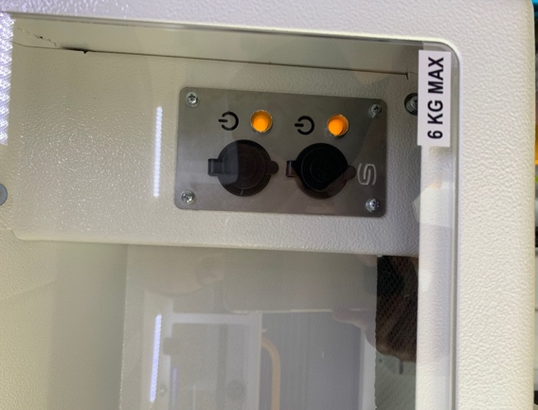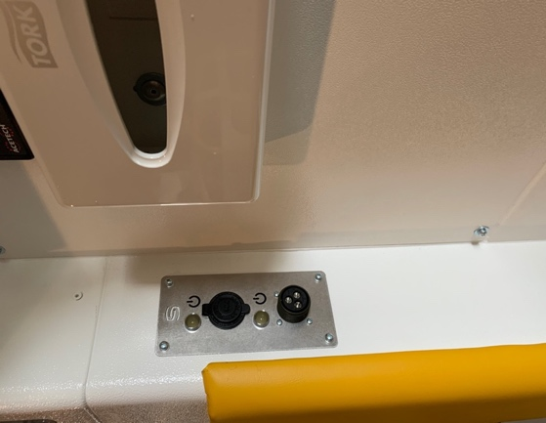

Batteries
The vehicles have been fitted with two batteries with similar charging characteristics can capacity. The original battery (OEM) is used for all the base vehicle functions.
The second or auxiliary battery is used for communications equipment, all emergency electrics/functions and the vehicle cooling cabinet.
Both batteries can be used for an emergency start of the vehicle when the “EMERG START” button is held down and the ignition is engaged.

240 Volt Inverter
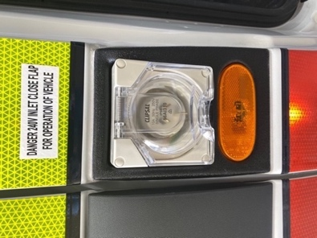
The vehicle is fitted with a 240 V 600 W sine wave inverter to power all the biomedical equipment on board. This unit is housed behind the driver’s seat and is turned on once the mains switch has been activated. The inverter is located within the communications locker
All the on board power points have inbuilt circuit breakers (RCDs) at the inverter and at their corresponding outlets for protection.

  - NOTE
Ensure inverter is left switched on and all plugs are left connected at the inverter unit itself. Since the 240 V inverter is controlled by the main switch, be aware that whenever this is on the power supply will be available at all power outlets in the patient compartment.

Coolant valve
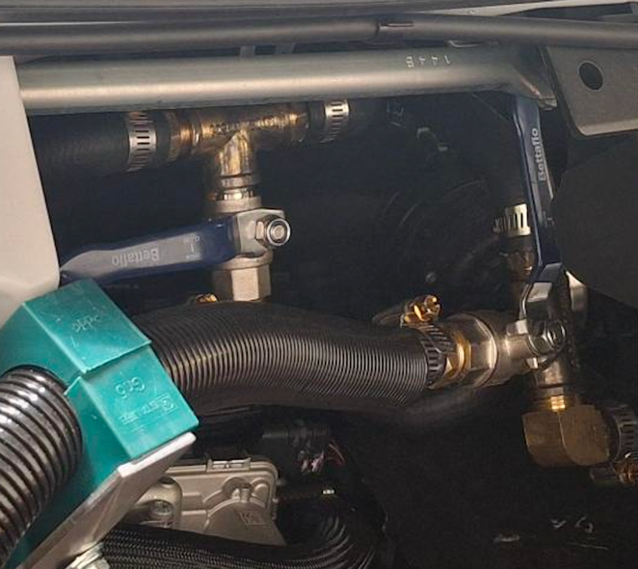
The coolant valve is located under the bonnet and has a blue handle that can be turned to close the valve, you can see them from drivers side close to the fire wall.

Battery Charger
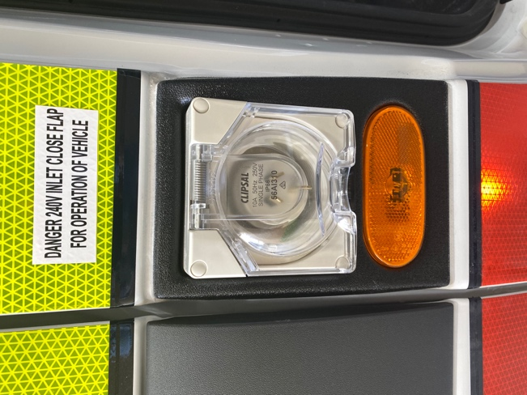
240V Inverter c/w inbuilt Circuit Breaker (RCD) . The dual output battery charger is located in the communications locker, behind the offside sliding door and is powered by an external 240 V power source. This unit is designed to charge both the original and auxiliary batteries but is only a trickle charger which is designed only to charge the batteries and no to maintain the power supply to the on board equipment.

  - NOTE
To ensure the battery system is maintained at its optimum state, the vehicle should be connected to an external power source whenever possible.

Interior Lighting

Ceiling
The vehicle comes with LED ceiling lights for low power requirements and can be operated from the drivers and patient compartments switch panels. These lights have low level light functions for a dimmed light.
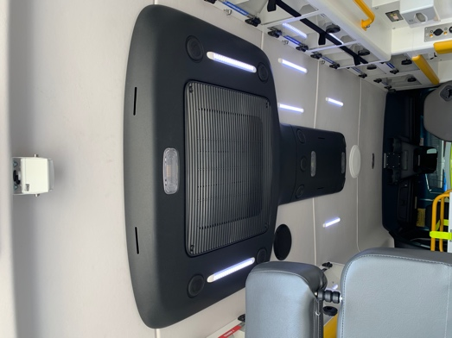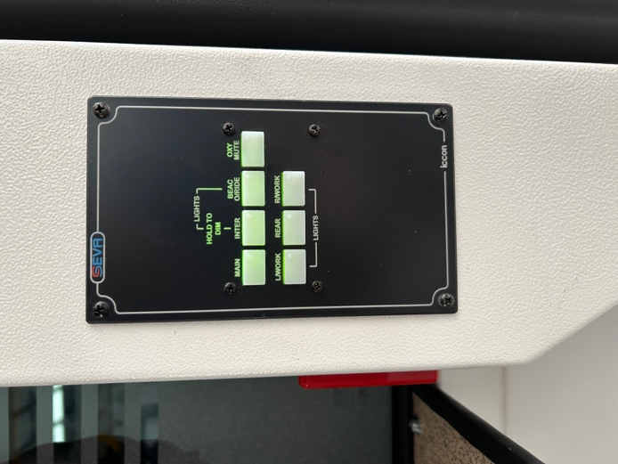

Driver and Co-Driver Map Reading Lights
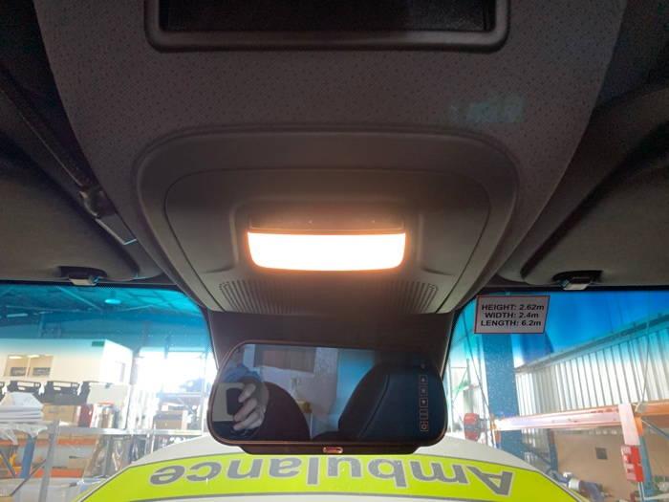
The map lights for the driver and co-driver are located on the ceiling above each seat.

Attendant Map Reading Lights
Map lights are fitted to the overhead lockers at each attendant’s seat location, which can swivel and rotate to direct the light to a desired position.

Exterior Vehicle Cleaning
The vinyl wrap on the exterior should be cleaned with non-abrasive products and harsh chemicals should be avoided. If vehicle is scratched the marks can be hard to mask. Recommended cleaners must be wet without solvents and have a pH between 3 and 11.
The windows should not be cleaned with abrasive products.

